***MUHAMMAD IRFAN***

A Proficient Mechanical Engineer

**E-** mail

Maken818@gmail.com

**Cell No.**

+92-341-6108061

**Date of Birth**

June06;1993

**CNIC No.**

38404-6188823-9

**Nationality**

Pakistani

**Religion**

Islam

**Languages**

English

Urdu

Punjabi

**Home Address**

**Vpo. sultanpur tehsil.shahpur district**

**Sargodha**

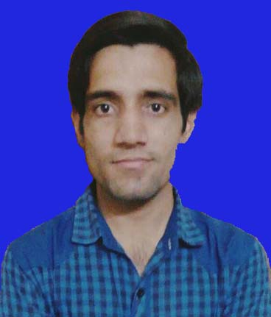***OBJECTIVE***

*“To obtain an entry-level position as a Mechanical Engineer with ABC Technologies, allowing me to utilize my education and internship experience while gaining valuable work experience in a forward thinking environment”*

***EDUCATION***

**2012-2016** *Wah Engineering College Wah Cantt*

**B.Sc Mechanical Engineering** CGPA:2.8(70%)

**2009-2012 misali barani science college;talagang**

**F.Sc**  Marks (818) Grade A(74%)

**2007-2009** *Govt. technical model high School, Jauharabad (Khushab)* **Matriculation** *Marks (778) Grade* **A**(73.8%)

PEC NO: Pec Registered Engineer MECH(33824)

***WORK EXPERIENCE***

**1 Year trainee Engineer at Waqas Interprises.PVt.lmtd.Islamabad**

**1 Trainee Engineer Experience At Heavy Industry Taxila (HIT)**

**Mechanical Engineer (Internee)**

Pakistan Ordnance Factories Wah Cantt

4-weeks

**Mechanical Engineer (Internee)**

Heavy Mechanical Complex Taxilla

4-weeks

***LEADERSHIP EXPERIENCE***

Mechanical professional *Society* in WE

***INDUSTRIAL VISITS***

***Pakistan Ordinance Factories****, Wah Cantt-Pakistan*

* 2-3 Visits were arrange by me for completion of my final year project.

4-5 official visits were arranged by college for practical study of machines working principles and different manufacturing processes.

**M**

**U**

**H**

**A**

**M**

**M**

**A**

**D**

**I**

**R**

**F**

**A**

**N**

C

V

***Ghazi Barotha Hydro Power Plant,*** *Ghazi Barotha-Pakistan*

* To study and visit the different parts of turbine
* To check out the practical working of turbines for generation of electricity
* To survey the dam i.e. gates of dam, pressure head etc.

***COMPUTER SKILLS***

* ***MAT LAB***: Average
* ***Turbo C++*** : Average
* ***Pro Engineer*** : Intermediate
* ***Microsoft Office (Doc , Exls and Ppt)***: Skilled

***Final Year Project***

* Design and Fabrication of Injection Blow Molding Machine

***REFERANCES***

* **Col. (R) Hafiz Sibghat Ullah Fazil SI(M)**

Head of Mechanical Engineering Department

Wah Engineering College, Wah cantt

**Email:** hodme@wecuw.edu.pk

* Further references can be provided on demand