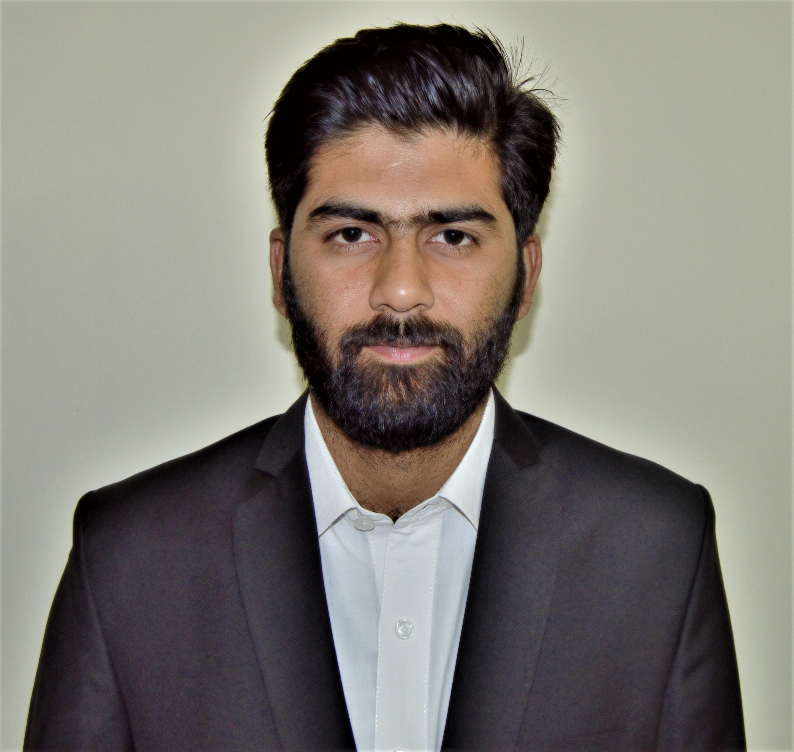**Muhammad Raheel**

Address : H # D-15 PEDO Colony Malakand-III HPC Dargai, Malakand

Cell No : 0345-5683514

Email Address : [raheelkhan4812@gmail.com](mailto:raheelkhan4812@gmail.com)

Age : 25 years

**Objectives**

I want to be a part of an organization that value the essence of Electrical Engineer as i have strange desire to contribute to the industry. I would sum myself up as good in communication skill self-motivated and result oriented with strong focus on acheiving goals. I am confident with my education, skills, experience that would be valuable for your company and my quality service background will allow me to contribute efficiently to serve the organization.

**Work Experience**

**Malakand-III Power Plant, Dargai**

Worked as a **Assistant Engineer**  in **AFI Norinco J.V**. Malakand-III Hydro Power Complex Dargai from 1st April, 2017 to 30th July, 2018 which includes

* Maintenance, Operation & testing of Power Plant Machinery & installed equipment
* Operation of Switchyard of 32MVATransformer,CT,s/PT,s /Switchgears /Isolators /SF6 circuit breakers/ PLC,s / CCTV etc
* Operation of 350*2 KVA Diesel Generator sets
* Operation of Excitation System, Governor System, different protection relays and sensors
* Assist in the overhaul of all (Electrical/Electronics) equipment in the Power House
* Identifying & taking appropriate measures relating to faults/abnormal situations
* Record malfunctions of the equipment, instruments or controls on log sheets
* SCADA system function and structure
* SCADA/DCS hardware and corrective maintenance
* Supervision and controlling of whole Power Plant through SCADA system
* DCS online test-Diagnosis, Data flow, Logic test, loading parameters
* Multi-Media Interface(MMI) construction and parameterization
* Taking Backup of SCADA Data base, maintain it on monthly basis
* Work on SCADA maintenance software SAT Toolbox-II, SAT SCALA 250
* Handling Information System called Maintenance Management System(MMS) as per requirements of Power Plant which comprises of Human Resource, Operation & Maintenance, Plant availability, Residential colony, Inventory, Library and User Management etc
* Provide technical support and assistance to team members

**ARKADASH International, Islamabad**

Worked as a **Site Engineer** at **ARKADASH (Consultants)** from 1st August, 2016 to

31st March, 2017 which included

* Supervision of LT/LV Panel Boards and Cable Networks
* Site Execution according to the drawing and specifications
* Load calculation and estimations
* Checking and verifying drawings
* Coordination with Civil and Mechanical Engineers for issues concerning Electrical installations
* Coordination with Consultants for contractual matters related to Electrical works
* Upgrading and compilng the daily, weekly and mothly progress report

**Education**

**Degree of Bachelor of Science in Electrical Engineering**

IQRA National University Peshawar, 2016

Cumulative GPA Score of **3.12** / 4

Registered Engineer (**Pakistan Engineering Council)** with **Reg No. ELECT/57934**

**Higher Secondary School Certificate**

WAPDA Degree College, Tarbela, 2012

Securing a total of 745 marks out of 1100 **(B Grade)**

**Secondary School Certificate**

WAPDA Senior Model High School, Tarbela, 2010

Securing a total of 745 marks out of 1050 **(A Grade)**

**Skills**

**Computer Skills**

* Microsoft Office (Word, Excel, Power Point)

**Technical Skills**

* AutoCAD
* Matlab
* Proteus
* Arduino
* PLC trainer

**Languages**

Urdu : Primary Language

Pushto : Mother Language

English  : Proficient Overall

**X-Factor**

Highly efficient in handling computers and latest technologies

Fast and self-paced learner for anything new and attractive

Hard working and always ready to go to the extra mile

**Strengths**

* Good Communication Skills
* Motivation
* Time Management
* Team Building Ability
* Diligent and Hard Working