**CURRICULAM VITAE**

**WAJI_UL_HASSAN**30th Sep, 1995.

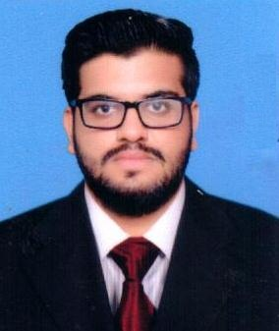**Personal information:**

|  |  |
| --- | --- |
| Father Name | Monem Saeed |
| CNIC | 35202-1960039-1 |
| Marital Status | Single |
| Religion | Islam |
| Address | 238-B Mamdot Block, Mustafa Town, Lahore, Pakistan. |
| Mobile | +923404259403 |
| Email | [wuhassan12@gmail.com](mailto:wuhassan12@gmail.com) |

**Objective:**  
“Apply the skills and knowledge developed through educational experiences to add value to your company and myself. To make sincere efforts towards building a promising career and to take challenges in life so that I can contribute to the growth and success of the company that I am working with.”  
 **Qualification:**

|  |  |  |
| --- | --- | --- |
| Education | Institution | Year |
| BSc. in Electrical Engineering | COMSATS Institute of information Technology, Sahiwal. (74.08%) | 2018 |
| FSC. | Unique college of computer sciences, Lahore. (65.36%) | 2013 |
| Matriculation | Unique High School, Lahore. (84.95%) | 2011 |

**Professional Experience:**

|  |  |
| --- | --- |
| Internship at Khairpur Sugar Mill (1 Month)   * Gained knowledge about AC motors and different sensors. * Gained knowledge and developed interest about Programmable logic controller. | 2016 |

**Working Experience:**

|  |  |  |
| --- | --- | --- |
| Semester Projects | Automatic street Light ,Home security Alarm. | 2014 |
| Semester Projects | Rain Detector, Fire Detector, Automatic car parking system. | 2015 |
| Semester Projects | Using Microcontroller making a digital clock. | 2016 |
| Final year Project | Monitoring and Controlling of Grain using PLC. | 2017 |

**Organizational visits:**

|  |  |
| --- | --- |
| Visit to Fatima Power Plant Snawan | 2015 |
| Visit to Engro Foods, Sahiwal | 2016 |

**Skills:**

|  |  |
| --- | --- |
| Computer | Proficient at MS office Suite. |
| Software | MATLab, Proteus, PLC trainer(Logix Pro, KGL WIN), Emulator8086 , MPLAB. |
| Documentation | Ability to produce reports and presentations of professional standard. |
| Analysis & Evaluation | Proficient in assessing data and formulating solutions. |
| Creativity | Ability to think in a creative way and simulate new possible development. |
| Organizational | Effective at time management and prioritizing tasks to meet the deadlines. |
| Compliance Dealing | Develop ability to deal efficiently the compliance procedures |
| Interpersonal/Communication | Strong team working, leadership and communication skills. |

**Achievements:**

|  |  |
| --- | --- |
| Received merit scholarships in school for first position. | 2009 to 2010 |
| Received merit scholarship in collage. | 2011 to 2012 |
| Received HEC scholarship. | 2014 to 2018 |
| Received PEC Number. Reg No : ELECT/68550 | 2018 |

**Sports:**Badminton, Cricket. **Interest:**Reading, Socializing.