MUHAMMAD SAQIB MURSALEEN

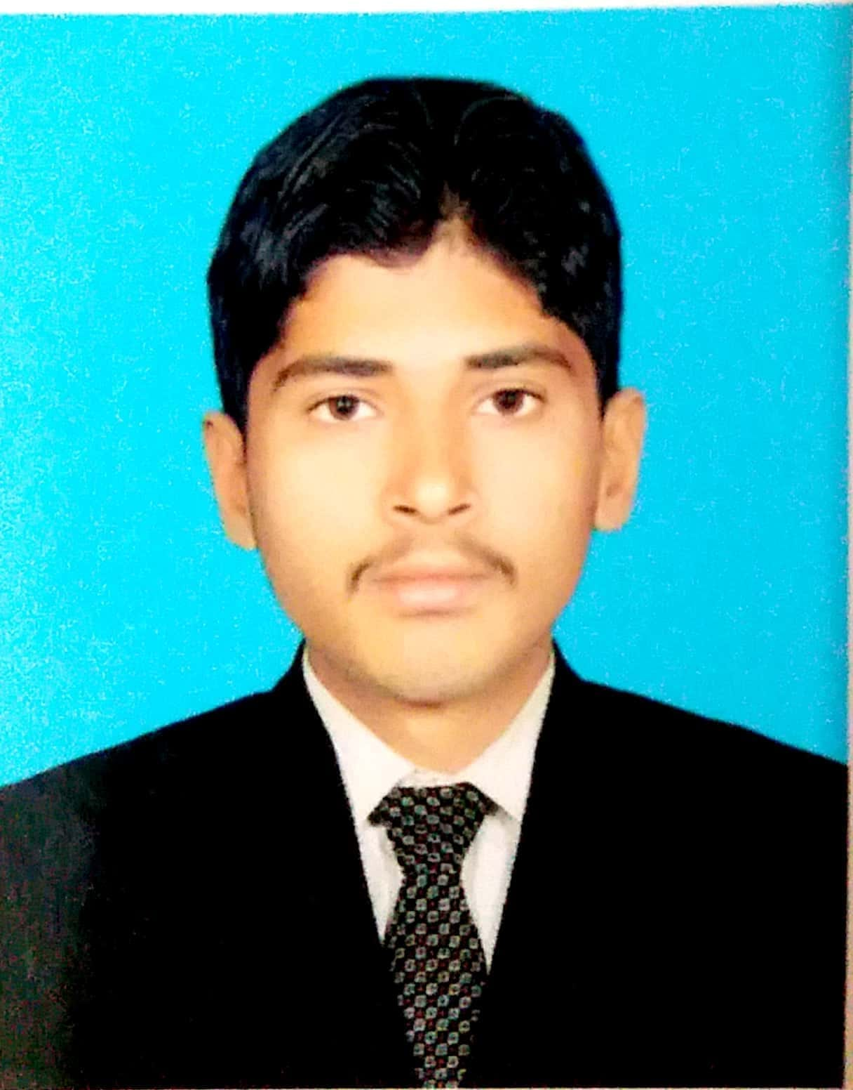

**Address:**  **Basti Islam Pur P/O Mubrik Pur Tehsil & District Multan**

**Cell #:** **0309-6751721 / 0336-7830093**

### **OBJECTIVE:-**

**To pursue career in a progressive organization that provides opportunities for career growth and professional development in order to groom the overall personality**.

### **ACADEMIC RECORD:-**

|  |  |  |  |  |
| --- | --- | --- | --- | --- |
| ***Degree*** | ***Year*** | ***Obtain/***  ***Total*** | ***Grad/***  ***%Age*** | ***Board/University/Institute*** |
| ***D.A.E (Mechanical)*** | ***2018*** | ***2815/3450*** | ***A*** | ***Punjab Board of Technical Education Lahore.*** |
| ***S.S.C.*** | ***2015*** | ***642/1100*** | ***C*** | ***Board Of Intermediate and Secondary Education Multan.*** |

**Internship:-**

**One month internship in Attock Refinery Limited, Morgah Rawalpindi.**

### **COMPUTER SKILLS:**

**MS Windows**

**MS Office**

**Internet**

### **SKILLS:**

**Entrepreneur spirit to fill the vacancy.**

**Ambitious and energetic.**

**Alert, dependable and quick**.

### **LANGUAGE SKILLS:**

**English**

**Urdu**

**PERSONAL INFORMATION:**

|  |  |
| --- | --- |
| **Father’s Name :** | **Muhammad Mursaleen.** |
| **Date of Birth :** | **06-06-1998** |
| **Domicile :** | **Multan (Punjab)** |
| **N.I.C # :** | **36302-4980968-9** |
| **Marital Status :** | **Single** |
| **Religion :** | **Islam** |

### **REFERENCE:**

**Will be furnished on demand**