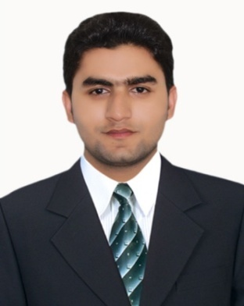

**Adeel Ashraf**

**CAREER OBJECTIVE**.

Seeking a job where I am able to implement my knowledge, experience & professional skills and demonstrate my strong commitment under a competitive and challenging environment

**ACADMIC QUALIFICATION**.

|  |  |  |  |
| --- | --- | --- | --- |
| **Degree** | **Year** | **Marks** | **Board/University** |
| Matriculation (Science) | 2014 | 734/1100 | B.I.S.E Multan |
| D.A.E(Electrical) | 2017 | 2701/3550 | P.B.T.E Lahore |

**EXPERIENCE**.

|  |  |  |  |
| --- | --- | --- | --- |
| **Organization** | **Designation** | **Department** | **Duration** |
| Thermal Power Station Muzaffargarh | Internee | Electrical Power | 2 Months |

**CERTIFECATION**.

Certification **City & Guilds** (Level 2) from Pak Arab Technical Training Institute Multan.

**INTERESTS**.

Book reading, News Papers, Tourism and Cricket.

**PERSONAL PROFILE**.

**Candidate Name :** Adeel Ashraf

**Date of Birth :** 26-09-1999

**C.N.I.C # :** 36302-1989827-5

**Domicile :** Multan (Punjab) Pakistan

**Marital status :** Single

**Religion :** Islam

**Nationality :**  Pakistani

**Cell # :** 0303-6539115

**Address :** House No 222, Block L, Shah Rukn.e.Alam Colony Multan

**LANGUAGE**. English, Urdu, Saraki & Punjabi

**REFERENCE**. Reference will be provided on demand.