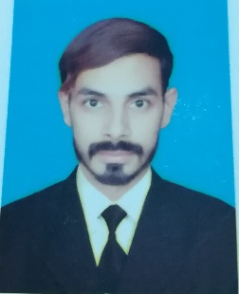

**Name: Waqar Ahmed Saif**

**Father Name: Saif-ud-din**

**Cell: 03024848020**

**DOB: 12-sep-1995**

**Email: Saif_waqar@ucp.edu.pk**

**Waqar121777@gmail.com**

**Home Address: Hs#27, ST#20, D-block,Al-Faisal Town, BaharShah Road, jurray pull Lahore cantt**

**Domicile: Punjab**

**OBJECTIVE**

To obtain a challenging leadership position to polish my skills and to to prove myself fittest for the job.

**EDUCATION AND QUALIFICATION**

University Of Central Punjab Oct 2014-july 2018

**Bachelors of Sciences Mechanical Engineering**

Punjab College of Science 2011-2013

**Fsc (pre-engineering)**

New Cantt Public High School 2000-2011

**Matriculation (Pre-engineering)**

**PROFESSIONAL EXPERIENCE**

No experience

**ADDITIONAL SKILLS**

* Quick learner
* Adaptable to change
* Skills of working in a group
* Microsoft Office
* Matlab

**LANGUAGES:**

* English
* Urdu

**HONORS AND AWARDS**

* Certificate for participating in UCP Olympiad

**PROJECTS**

* Built a truss bridge in 2nd semester
* Built a roller coster model in 3rd semester
* Built a Can crusher machine in 5th semester
* Built a Checking Fixture In Final Year Project

**REFERENCE**

Will be furnished upon request