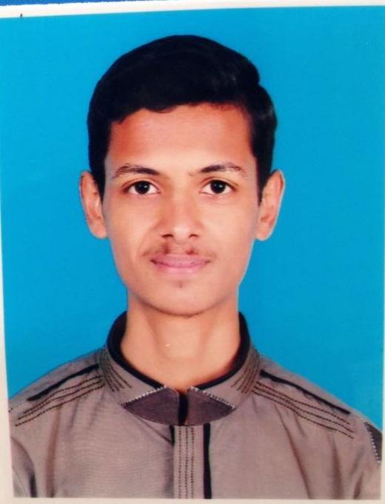

**HAMZA KHALID**

OBJECTIVE:

Accept and enjoy the new challenges and situation. Make a positive contribution towards the given situation, increase the wealth of the organization and enhance the knowledge, abilities and skills through organization by contribution.

PERSONAL BIO DATA:

Name : HAMZA KHALID

Father Name : KHALID MEHMOOD

Cnic No : 37102-1626333-9

D-O-B : 15-01-1999

Religion : ISLAM

Nationality : PAKISTANI

Domicile : PUNJAB(ATTOCK)

Address : KHOR ROAD Near Al Murtaza Masjid FATEH JANG

Email : khalidhamza851@gmail.com

Contact No : 03487989574

QUALIFICATION:

|  |  |  |  |
| --- | --- | --- | --- |
| **DEGREE** | **YEAR** | **MARKS** | **BOARD** |
| **SSC(SCIENCE)** | **2015** | **717/1100** | **BISE RAWALPINDI** |
| **DAE(MECH)** | **2018** | **2589/3450** | **PBTE,LAHORE** |

**OTHER CERTIFICATES:**

* OFFICE AUTOMATION

**LAUNGAUGE:**

* URDU [EXECELENT]
* ENGLISH [GOOD]

**Computer Comprehension Command On:**

* Operating System
* MS Office
* Installation of Software

**PERSONAL ATTRIBUTES:**

* + Hardworking, Reliable and Dedicated.
  + A Self Motivated Individual.
  + Good Communication and People Oriented Skills.
  + An Eager and Quick Learner.
  + An Organized Person.

**REFERENCE:**

**Reference will be provide on your demand.**