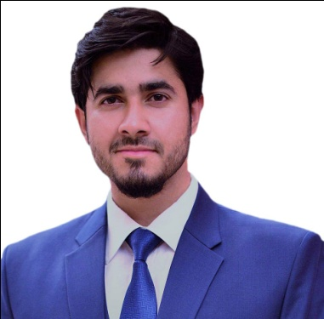**CurriculumVitae**

**Aashir Ali**

**BS(Electrical Engineer)**

House 241, Street 31, Sector I-8/2 , Islamabad

Email: [aashirali95@gmail.com](mailto:aashirali95@gmail.com) Cell*+*92-3105855955

**CAREER OBJECTIVE**

To pursue a career in Electrical Engineering, contributing positive changes and maximize my skills and experiences for optimum benefits and growth of the organization.

|  |
| --- |
| **PERSONAL INFORMATION** |

* S/O Iftikhar Ahmed Shahid
* DOB 16-01-1995
* CNIC 34101-8391051-3
* Religion Islam
* Marital Status unmarried

|  |
| --- |
| **EDUCATION** |

|  |  |  |  |  |
| --- | --- | --- | --- | --- |
| **Degree** | **Field of Study** | **Degree/Certificate Awarded by** | **CGPA/%age** | **Passing Out Year** |
| Bechular’s of Science | Electrical Engineer | COMSATS UNIVERSITY | 2.95/75.61%  (CGPA) | 2017 |
| HSSC | Pre Engineering | FBISE, Islamabad | 63% | 2013 |
| Matric | Science | FBISE , Islamabad | 77 % | 2011 |

|  |
| --- |
| **PROFESSIONAL EXPERIENCE** |

* Worked as Trainee Electrical Engineer at Heavy Industries Taxila (HIT) ministry of defence 1 year from July 2017 to june 2018. During training had hand on experience on:
* Advanced System Rebuilt Factory (ASRF) Production Shop
* Designed the layouts of PCB of the assembly PD box(Tk. Al-KHALID).
* Inspection of assemblies i.e. Fire Control Computer (FCC), Control box and Sensors (Cross Wind, Angular Velocity and Tilt Sensors) of Tk. T85 UG, Tk. AL-ZARAR , AL-KHALID.
* Inspection of assemblies i.e. Gun Control Unit (GCU), Transistor Driver, Turret Motor, Voltage Booster, Angle Limiter, Electromagnetic Clutch & Gyro Motor.
* Repairing of Test benches of assemblies of Tk. T85 UG, Tk. AL-ZARAR, AL-KHALID.

➢Hands on experience at Margala Textile mills as internee (2 months) in following divisions:

• Power generation house

• Repairing Lab

• Maintenance & instrumentation department

|  |
| --- |
| **FINAL YEAR PROJECT** |

➢Designed a 3 Phase Variable Frequency Drive of Squirrel Cage induction Motor.

This includes knowledge and hands on experiencewith:

* PIC controller
* Induction motors
* H-Bridge
* MOSFETs/IGBT
* Opto Couplers
* Power Supply Unit

|  |
| --- |
| **MINI PROJECTS** |

➢Worked on various mini projects during my academic career. Listed are thefollowing:

• Solar Battery Charger

• Induction motor by pass circuit(protection)

• Fire Alarm using OP-AMP

• Digital Clock

|  |
| --- |
| **PRESENTATIONS & REPORTS** |

➢Designed and delivered many PowerPoint presentations & reports during my academiccareer. Listed are thefollowing:

• Holography

• Barometer

• Transducers in instrumentation

• Stress management

|  |
| --- |
| **PROFESSIONAL SKILLS** |

* Ability to work collaboratively in team environment.
* Excellent communicationskills.
* Decision making and problem solving skills
* Confident and Highly motivated

|  |
| --- |
| **COMPUTER SKILLS** |

➢LABView, Proteus, Electronics Work Bench, MATLAB ,Xilinx

FPGA , VHDL

* Microsoft Office (Excel, Word, Power Point)

|  |
| --- |
| **EXTRA CURRICULAR ACTIVITIES** |

➢Reading English articles Pakistani & international newspapers

➢Reading Electrical Engineering magazines

|  |
| --- |
| **LANGUAGES** |

➢ English(Proficient), Urdu (National Language)

|  |
| --- |
| **REFERENCE** |

* Will be provided on demand