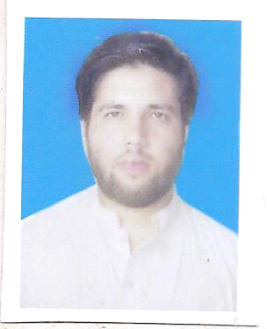

***Zul Qarnain***

**E-mail:** [**zulqarnain.uet@gmail.com**](mailto:zulqarnain.uet@gmail.com)

**Contac No: +923006596884**

**OBJECTIVES**

To work in a congenial and dynamic environment proving my professional skills with a view of refining my knowledge, besides seeking a long-term career oriented relationship with the organization where I can share my knowledge to organization.

**Working as a Management Trainee Officer at Saima Packaging Private Limited Karachi(From December 2016-February 2018)**

**Job Responsibilities:**

* Reporting to Shift Supervisor For All Production And Maintenance Activities.
* Monitoring and Evaluating the Performance of Various Process Equipment’s like Distillation Column, Heat Exchangers, Pumps, Compressors, & Hot Oil Heater Etc.
* Planned And Directed the Regular Checking and Recording of Various Flows, Levels, Pressure and Temperature to Ensure They are Within Specified Operating Limits.
* Follow Up the Daily Reports And Perform the Necessary Action by Analysis and Troubleshooting if Any Abnormality Has Appeared.
* To Carry Out Safe And Smooth Operations of Amine Unit And LPG Unit By Trouble Shooting Pro-Actively.
* Daily Routine Check-up Of All Equipments.

|  |
| --- |
| **Operation System & Control System** |

**PLC Based Control System ( DIA.NE)**

**Engine Control System**

|  |
| --- |
| **Projects** |

***Commissioning For New XL-106***

* Supervised Electrical Supply System, Ducting, Floor Levelling etc
* Successful Commissioning and Start Up

|  |
| --- |
| **Internee at National Transmission and Despatch Company(March 2016-September 2016)** |
|  |

* **Started Training in 220kv Grid (NTDC) Mardan Pakistan**
* **Field Training includes:**
* Studying and observing installation of 250MVA transformer at 220kv Grid Mardan
* Basic knowledge of power transformer and its accessory
* Learning about different tests on bushing CT i.e. saturation test, ratio test, polarity test, continuity test, C&DF test
* Learning about Megger test, C&DF test, TTR test on power transformer
* Learning about dehydration of power transformer oil and testing for dielectric strength test
* Studying and practical work carried on station batteries i.e. specific gravity, ampere hour, volt/cell
* Learning basic knowledge of C.T, P.T, Circuit breaker, Isolators

**EDUCATION**

* **BE Electrical Engineering(2.81/4.00)**
* **Intermediate 796/1100**
* **Metric 661/1050**

**COMPUTER SKILLS**

* Microsoft Word, Microsoft Excel, Microsoft Power Point
* C++, Mat LAB

**LANGUAGES SKILLS**

* English, Urdu, Pashto