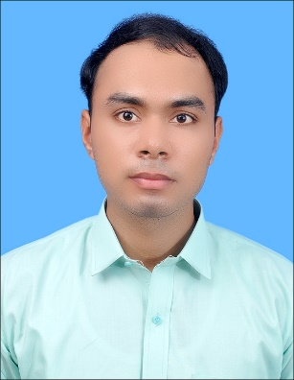**Abdul Wahab**

**E-mail id:** [**abdul.wahab41177@gmail.com**](mailto:abdul.wahab41177@gmail.com)

**Ph. 0309-4852844**

**Address: Housing Colony Near Faizan-E-Madian Taj Mehal Colony Jranawala, Faisalabad.**

**Career Objective:**

To be an expert in practical field through commitment and continuous improvement.

**Professional Education:**

**2014 – 2018** **BS (Electrical Engineering)**, University of Lahore (UOL),

**Waiting for Result**, **(CGPA 3.09).**

**2011-2013** **F.Sc (Pre.Engineering)** , Govt. College Jaranwala

Faisalabad, Marks(755/1100), **1st Div (Grade B).**

**2007-2011** **Matric(Science)**, Al Raza Higher Secondary High School

Jaranwala,Faisalabad,**Marks(874/1050), 1stdiv(Grade A+)**

**Final Year Project:**

1. **Three Phase Control of Power Inverters (Using D-Q Transformation)**

**Project Description:**

With the advancement of the technology in renewable energy sources DC-AC converters are gaining a lot of attention especially in third world countries and becoming a very hot topic for the researchers. These Renewable energy sources are not connected directly with conventional micro grids. For this purpose, DC-AC inverters are connected to the voltage. A power electronic ﬁlter along with control scheme A DQZ transformation technique is proposed as a new approach to improve the voltage stability of a DC-AC three phase inverter. The propose technique converts the three phases into two DC phases D phase and Q phase which includes all the information of three phases. These phases are compensated using PID control technique and provides a reference to the PWM of inverter. This feedback technique controls the voltages drop of inverter when a load is connected. Harmonics are removed using LC resonate filter technique in this way voltages are stabilized and harmonics are reduced to take the output voltage to maximum perfection.

**Skill:**

1. MS offices **2.** MATLAB **3.** Proteus **4.**Strong hardware

**Interesting Subjects:**

1. Power system.
2. Power plant engineering.
3. Power system Protection.
4. Power System Analysis.
5. Instrument and Measurement.
6. AC and DC Machines.

**Experience:**

* Three week “INTERSHIP” at university of Lahore Innovative center.
* One Month “INTERSHIP” at RAFHAN MAIZE PRODUCT.
* One week at “Thermal Power Complex Faisalabad”.

**Academic achievement:**

* Secure 1st position in “**Technical paper presentation** “organized by GIKI University in 2016 under **IEEE.**
* Secure 1st position in **“Circuit implementation competition”** organized by GIKI University in 2016 under **IEEE.**
* Runner up in **“Pandora Box”** organized by GIKI University in 2016 under **IEEE.**

**Personal Data:**

* Father Name: Ghias Muhammad
* CNIC: 33100-2855869-5
* Date of Birth: 7th OCT, 1993.
* Marital Status: Single.
* Hobbies: Books reading , Cricket.

**Reference:**

Reference will be furnished when required.