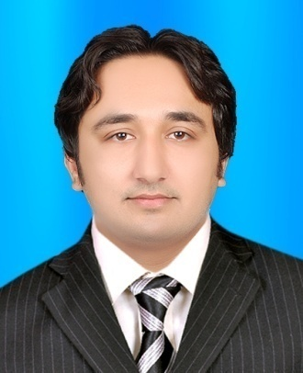

**HASSAN ALI**

**(Electrical Engineer)**

+92-3337136777/+92-3073729842

Hassanalvialvi@gmail.com

Aiming to develop as a true professional in the field of Electrical Engineering by utilizing my strong technical skills in a professional environment. I aim to achieve a stature in the field that will make my name glow among the legends of profession.

# Final Year Project/Thesis

# TECHNICAL STUDY OF PROTECTIVE SCHEMES FOR 500KV SWITCHYARD GUDDU POWER PLANT

Roles & Responsibilities**:**

* Preparing detailed technical contents describing in and out of the draft.
* Gained knowledge about Substation Switchgears faults and its maintenance.
* Ensured that the products were installed correctly and tested them.
* Coordinated with the contractors ,consultants, architects ,clients and suppliers and maintained good working relations.
* Prepared Technical Submittals & Shop Drawings for Approval.
* Co-ordinated with consultants for the Field and Material Inspection for the completion of the projects.
* Gained knowledge about Substation Switchgears faults and its maintenance.
* Submitting the finalized project to the concerned senior officials.

# Short Trainings

Introduction to MATLAB/Simulink for modeling and simulation.

PLC Introduction Principles &Applications

# Professional Skills

* Ability to work independently as well as part of a team
* Hard working nature, professional and positive attitude.
* Excellent oral and written communication skills.
* Strong supervisory, time management, and coordination skills.
* Remarkable planning and organizational skills.
* Excellent knowledge of computer use with windows OS (Vista, 7, 8 & 10).
* Advance use of Microsoft office (2007 , 2010 & 2013).
* Sound knowledge of health & safety and quality issues of project site.
* Possess effective presentation, verbal and written communication skills.
* Have ability to successfully manage multiple priorities and assignments.
* Good knowledge of leading a team in a team oriented work environment.

**Education**

* B.E Electrical Engineering from Quaid-e-Awam University of Science and Technology Nawabshah Pakistan 2016, 76.44%
* H.S.C(Intermediate) Pre-Engineering from B.I.S.E Sukkur in 2011, 75%
* Matriculation from B.I.S.E Sukkur in 2009, 73%

**Languages:**

* English (Speak & Write)
* Urdu (Speak & Write)
* Sindhi (speak & write)

**Personal Information;**

* **Father Name**: Muhammad Khalid
* **Caste** : Alvi
* **DOB**: 20-09-1992.
* **CNIC #** :45501-1553704-1
* **Passport number**: QU1817041
* **Marital status**: Single
* **Nationality**: Pakistani.
* **Address**:FOUJI MUHALLAH SHAHI BAZZAR PANOAKIL SINDH PAKISTAN.

**REFERENCES:**

References can be provided on demand.