**Muhammad Nouman**  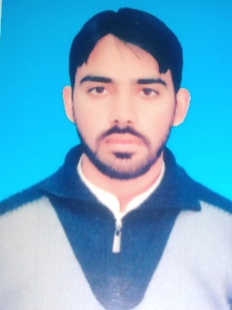

**m.noumankhan011@gmail.com**

+923169981911

House # C123, GBHP wapda colony, Distt , Attock.

**EDUCATION**

|  |  |  |
| --- | --- | --- |
| Degree | Year | University/College |
| Bachelor in Electrical Engineering | 2014-2018 | Comsats University Attock campus |
| FSc Pre-Engineering | 2012-2014 | Peshawar cambridge Degree college |
| Matric | 2010-2011 | Wapda English Medium School GBHP colony, Dsit Attock |

**TECHNICAL SKILLS**

* Matlab software
* Labview software by NI,USA
* C, C++ , Arduino
* PCB designing, Proteus and PSpice

**Personal Skills**

* + - * Flexible Schedule
      * Open Minded
      * Strategic Thinker
      * Team work

**WORK EXPERIENCE**

* LAB engineer at NEELAB institute of information technology.

 **PROJECTS**

* + RFID base mobile charging system (semester project)
  + Micro Controller (ARDUINO) based Line follower Robotic Vehicle (semester project)
  + Voice base home appliances control system ( Final Year)

**REFRENCE(s)**

* Professor AurangZaib,Dept of Electrical Engg ,Comsat Attock  **+923339149417**