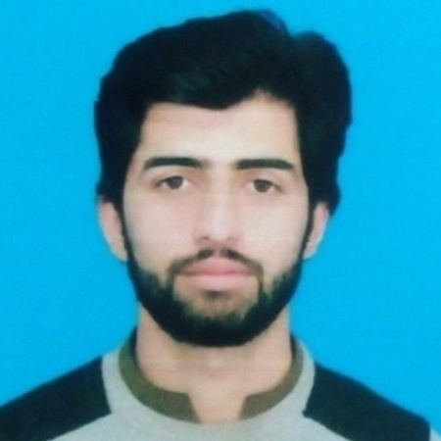**CURRICULUM VITAE**

ENGR. ZEESHAN ZAFAR

ELECTRICAL ENGINEER

PEC No: ELECT/57374

Mobile: +92315-9283262

Address: House # 255-A Phase 1 Armour Colony Manki Road Nowshera

Email: [zzshani93@gmail.com](mailto:zzshani93@gmail.com)

### **Career objective**

Seeking a challenging Technical position in a dynamic organization with the aim to contribute towards organizational success by enhancing ethical and competency standards in client services, to perform consistently and meet the organization’s expectations.

### **ACADEMIC QUALIFICATION**

**Masters (MS Electrical Energy System Engineering): (2018-2020)**

From USPCAS-E UET Peshawar (In progress)

**Bachelors (B.Sc Electrical Engineering): (2012-2016)**

From Mirpur university of science and technology AJK, Pakistan obtaining CGPA of 3.50/4.00.

**Intermediate (F.Sc Pre-Engineering): (2008-2010)**

From Board of Intermediate & Secondary Education, Mardan and obtaining 856/1100 marks.

**Matriculation (SSC Science): (2006-2008)**

From Federal Board of Intermediate & Secondary Education, Islamabad and obtaining 681/850 marks.

### **PREVIOUS JOBS**

* Worked as NIP Internee at NIST Pabbi Nowshera (14th July 2017 - 30th June 2018)
* Pakistan WAPDA Foundation Workshop Nowshera (26th June 2015 – 24th August 2015)
* Islamabad Electric Supply Company Islamabad (2nd September 2015 – 1st October 2015)

### **PROJECT UNDERTAKEN**

* Design of Smart Load Management and Power Saving System
* Digital Voting System
* Sequence Recognizer
* Self Switching Power Supply

### **EXTRA-CURRICULAR ACCTIVITY**

* Attended Second National Conference on Green Energy Technologies by USPCASE UET Peshawar, Seminar on Power Projects by Laraib Energy Limited and Leadership Capabilities by Pakistan Engineering Council.
* Attended Workshops on Word press, microcontroller programming and Printed Circuit Board (PCB).
* Participated in different events held in MUST Mirpur Azad Kashmir, FAST Lahore and GIKI Sawabi.
* Visited Mangla Power House, Wapda Academy Faisalabad, The New Bong Escape Hydroelectric Power Project Azad Kashmir and Neelum Jehlum Hydro Power Project Muzaffarabad during B.Sc Electrical Engineering.
* Hockey and Table Tennis Departmental Team Captain

### **TECHNICAL SKILLS**

* MS Office (MS Word, MS Excel, MS PowerPoint)
* PCB Designing
* C++ Programming
* Installation of Solar Systems

### **INTERPERSONAL SKILLS**

* Ability to work both independently and as a team member.
* Excellent communication skills.
* Dynamic leadership qualities.
* Excellent analytical and motivational skills.
* Fluent in English, Urdu & Pashto .

### **PERSONAL INFORMATION**

Father Name: Zafar Iqbal

Nationality: Pakistani

Domicile: Nowshera

National ID card No: 17201-8758056-5

Marital Status: Single

Date of Birth: 06th February, 1993

### **REFERENCES**

Available on request