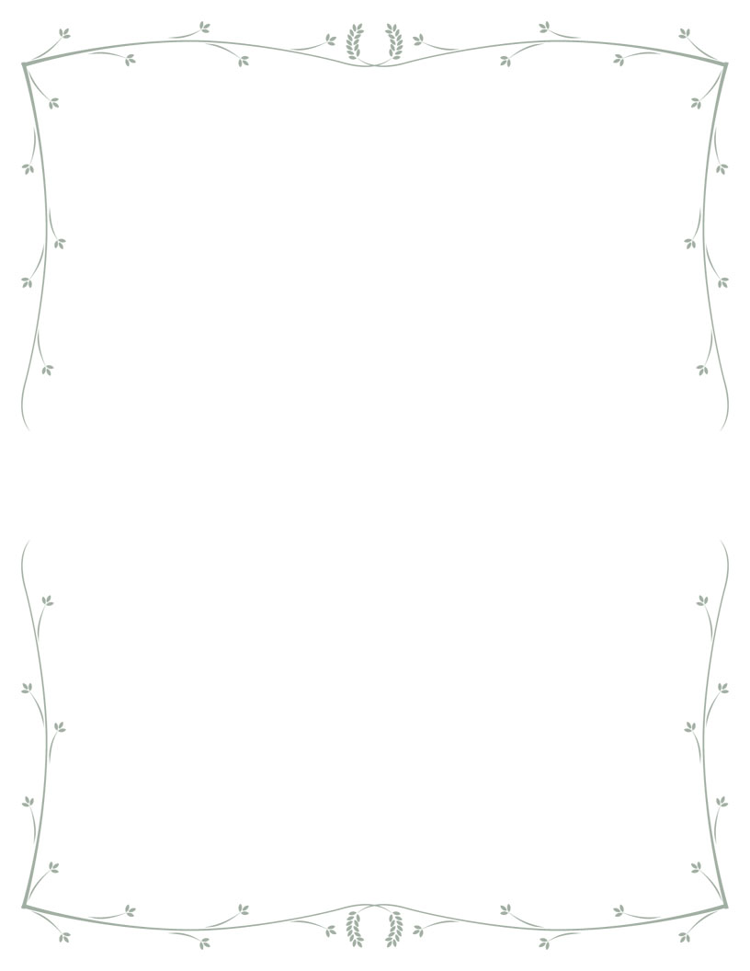***CURRICULAM VIATE***

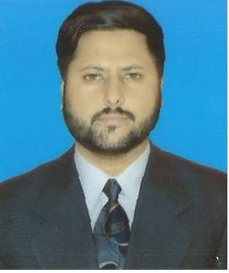**ZUBAIR KHAN**

Moj-e-Derya Mohala Tehsil:Jand Distt:Attock

0333-2185507, 0092-345-0225839

Zubimir3@gmail.com

**OBJECTIVE:**

Seeking a responsibility and challenging position in an established organization that will utilize my skill and experience in any field in accordance with my work experience and educational qualification.

**PERSONAL DETAILS:**

Name : Zubair khan

Father’s Name : Haji Zaheer uddin

Date of Birth : 20/11/1992

Nationality : Pakistani

Sex : Male

Marital Status : Single

NIC no : 14301-8558282-1

**Education:**

**Bin Qasim Secondary School S.S.C (Karachi Board)**   
Certificate: Matriculation Grade (A) Marks. % 92 Dates: ANNUAL EXAMINATION 2009

**Professional Calcification**

3 years Diploma1st Division DAE: Passed Diploma of Associate Engineer in Mechanical from Government College of Technology KOHAT. Since May 20/06/2014 TO 05/05/2017