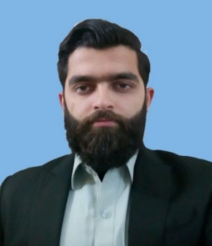**Fahad Hassan**

**+92-315-9608552, fahadhassan777@yahoo.com House # 15,Malik Aziz ullah colony swati gate Peshawar Cantt.**

***Education***

|  |  |  |
| --- | --- | --- |
| **FAST – National University of Computer and Emerging Sciences, Peshawar** | | |
| **Bachelor of Science (Electrical Engineering)** | | **2018** |
| **Major** | -Power Electronics, Electronic circuit design, Industrial process control, Electrical power, Digital signal processing. |  |
|  | |  |
| **Fazaia Degree College, Peshawar** | | **2013** |
| **FSC -** [Computers, Mathematics, Physics, Chemistry] | |  |
| **Fazaia Degree College, Peshawar** | | **2011** |
| **Matric -** [Mathematics, Physics, Chemistry] | |  |
| ***Projects*** | |  |

***Final Year Project:* IOT (Internet of Things) Based Load Management And Net-Metering Of Electrical Power.**

Basically in this project we have done the implementation of control for smarter grid capable to control the direction of power flow. Load management in maximum demand or during emergency situation. A passive consumer become an active consumer.

***Semester Projects:***

**Smoke Detector:** A device which detected diffenrent types of gases.

**Fluid Level Indicator:** A device which detects the level of different fluids.

**Traffic Light Control System:** Traffic is controlled through different signals lights.

**Wireless Motor Control System:** The motor is controlled through wifi.

**Automatic Street Lightning System Using IOT:** It automatically switches the street light ON and OFF based on the amount of sunlight present.

***Skills & Tools***

Visual Studio, MATLAB, Photoshop, Cisco Packet Tracer, C++,Assembly Language,Aurdino,MS Office[Word,Exel,Power Point].

***Training / Certification***

Attended seminar on “Aurdino”

Attended seminar on “PLC”

***Activities***

|  |  |
| --- | --- |
| Ticketing Head NUTEC’18  Vice President Of Sports Society. | **2018**  **2018** |
| Decor Head Farewell 2k17. | **2017** |
| Security Head Farewell 2k17 | **2017** |
| ***Interests*** |  |
| Playing badminton, cricket and strategy games |  |
| Reading novels and fiction |  |
| Photography |  |