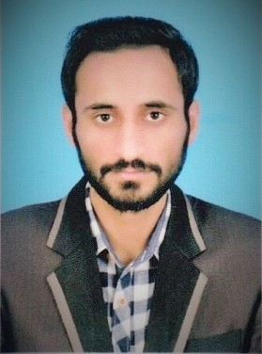 **Engr. RAFI ULLAH**

**(PEC Registered Engineer)**

+923152456260 • [rafiobaid999@gmail.com](mailto:rafiobaid999@gmail.com)

• Age: 22

**Objective:**

*To work in an organization which gives me a platform to enrich and utilize my overall skills in such a manner that it proves to be an asset in every state of the business, thus allowing me to give my best for the growth of the organization. I am looking for a good opportunity where I can further develop my skills more*.

**Education:**

**UNIVERSITY OF THE PUNJAB** Lahore, Pakistan

*Bachelor in Chemical Engineering CGPA 3.32*  2013-2017

**ARMY PUBLIC SCHOOL & COLLEGE** Gilgit, Pakistan

F.sc A Grade 2011-2013

**Experience:**

* **Internship at Pakistan steel Mills, Karachi.**

**Academic Activities:**

**FINAL YEAR PROJECT:**

* **Plant design for the extraction of essential oil from 100kg of orange peels.**

This was a group project, we were four members & I was group leader. In this project we theoretically design a chemical plant for extraction of essential oil from orange peels. The plant consists of Charge Vessel, Condenser, Collector, separator & Storage Tank. We design each equipment in great details. Finally, we also estimated cost required for the designing of each equipment.

**PROCESS REPORT:**

* **Extraction & Analysis of essential oil from orange peels.**

it was a group task & I was the group leader. In this assignment we studied different kinds of essential oils that can be extracted and can be used in different products of daily life. After getting knowledge of different essential oils we tried to produce essential oil in our Lab, so we choose orange peels for this purpose and extracted oil from it by steam distillation & water distillation. Finally, we find the concentration of different compounds in the oil by Gas-Chromatography.

**Honors and Awards**

**ACADEMIC SCHOLARHIPS**  Lahore, Pakistan

Received the HEC scholarship during the University period. (2013-2017)

Received the Fauji Foundation merit scholarship at college level.

**PRIME MINISTER’S AWARD** Lahore, Pakistan

Received merit-based Laptop Award from Prime Minister 2015

**Additional:**

\

* ***Interpersonal Skills:*** Excellent Communication, Management, Leadership, Team work, , Creativity.
* ***Technical Skills:*** Microsoft office Proficiency, AspenHYSYS, ChemCAD, MATLAB, Visio, Software Installation.
* ***Interest:*** Book Reading, Cricket, Foot Ball, volleyball, Table Tennis, Attending social Event.

**Reference:**

* **Engr.Muhammad Mashroof**: Safety Officer at Pakistan Atomic Energy

Contact No: +923335708806, +923118752221

* **Engr.Shahid Nasim**: OIC GSM At SCOM Telecommunication Company

Contact No: +923555101544

* **Engr.Waqar**: AM at ZTE Pakistan,

Contact No: +923103018143