# FAISAL AKRAM

**Address: -** *Mohallah Kashif Abad, Rakh Tara Garh, P-O Box Hernal*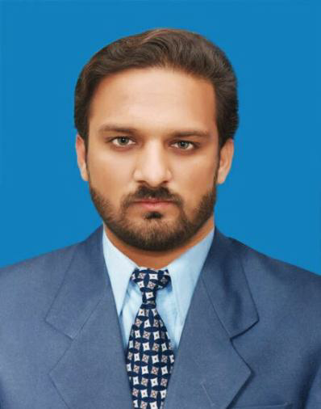

*U-C Sahang, Tehsil Gujar Khan, District Rawalpindi*

**Father Name**: *Muhammad Akram*

**Contact No**: *+92-306-7473865 +92-333-7641634*

**Citizenship:** *Pakistani*

**Passport No:** *EG1324971*

**CNIC:** *36302-6266497-5*

**Date of Birth:** *22-11-1992*

**Marital Status:** *Single*

**Email Address:** *faisalakram784@yahoo.com*

# PRPFESSION: MECHANICAL ENGINEER

# CAREER OBJECTIVE

*I am a Mechanical Engineer seeking a place where I can utilize my strong mathematical modeling skills and technical knowledge, to improve the efficiency and reduce the cost of the product and to secure a promising position that offers both a challenge and a good opportunity for the growth and advancement.*

# PROFESSIONAL CAREER

Working Under **EDO Office Rawalpindi** from July 2017 to **TILL NOW**

*Worked as Trainee at* **THERMAL POWER STATION MUZAFFARGARH** from **27-09-16 to 26-12-16**

*I attended training sessions at TPS also visited;-*

**Pump House**

*Function of pump, Water and lube oil system*

**Cooling Tower**

*Function of cooling tower, circulation of water, Machine lubrication system*

**Boiler**

*Function of boiler, tubes, water cycle, oil cycle, steam drum and cycle, ID & FD fan*

**Mechanical Workshop**

*Question answer session Knowledge during maintenance of equipment’s*

*Types of bearing: - General bearing (white metal), tilting pad thrust bearing, roller bearing and ball bearing*

*Types of Valves: - Gate valve. Globe valve, Drain valve, NRV*

*Types of Filters: - Rough and Fine filters*

# ACADMIC RECORD

**BS MECHANICAL (Bachelor of Science in Mechanical) Technology 2012 – 2016**

From: - Institute of Southern Punjab Multan

With **CGPA 2.97/4.00**

**DAE (Mechanical Engineering & Technology) 2009 - 2012**

From: City College of Technology Multan

With **1st** division Marks **2415/3350**

## Matriculation (Science) 2009

From: BISE Multan Board

With **2**nddivision Marks **612/1050**

# BS MECHANICAL FINAL YEAR PROJECT WORK21

**DESIGN AND FABRICATION OF BIOGAS POWER PLANT**

**BIOGAS Formation**

Production of gases from Animals Dung

**Purification of Gas**

Reduction of moisture content, hydrogen sulfide content and carbon dioxide content

**Power Generation**

Direct combustion and heat, combine heat and power generation, gas Otto engine

# *OTHER COMPUTER EXPERTIES*

MS OFFICE (Word & Excel)

* *Downloading and uploading*
* *Software Installations*
* *Typing speed 40 WPM*
* *Basics of Computer Emailing and Hardware*

# *PERSONAL INTEREST AND ABILITIES*

* *Self-motivated, self-confident and self-learner*
* *Ability to work in Stressful Environment*
* *Open to learning and exploring new technology*
* *Effective communication skills*
* *Reading Books, Newspaper*