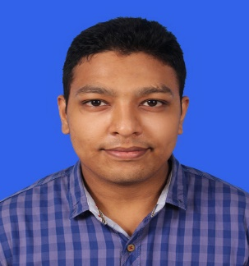**SYED SHAHEER KAMAL**

Date of Birth: October 15th 1994.

Email address: [syedshaheerkamal@gmail.com](mailto:syedshaheerkamal@gmail.com)

Address: House#A1/36, Madras Society, Gulzar-e- Hijri, Karachi, 75330.

Cell # 0333-0240362.

**CAREER OBJECTIVES:**

* To be a part of an organization where I can fully utilize my skills and make a significant contribution to the success of the employer and at the same time my individual growth

**PROFESSIONAL QUALIFICATION:**

* B.E Chemical from University of Karachi with “**3.08**” CGPA in the year (January) 2013-2017.
* Pursuing M.E Chemical From NED University of Engineering and technology from 2017 to present.

**ACADEMIC QUALIFICATION:**

* HSC (Pre- engineering) from Govt. Degree Boys and Girls College Gulshan-e-Iqbal, Block 7 with “**A**” Grade in the year 2012.
* SSC (science) from All Saints School with “**A”** Grade in the year 2010.

**FINAL YEAR THESIS PROJECT:**

“**Design and comparative study of a Nitrogen rejection unit for 100MMscfd Natural gas”**.

* Design of pressure swing adsorption column and cryogenic unit to prepare the gas for pipe line specifications.
* Comparison of both pressure swing adsorption and cryogenic distillation technique on the basis of economics, performance, feasibility etc.

**EXPERIENCE:**

Worked as a Trainee in SGS Pakistan (Pvt) Limited from 10/2017 to 06/2018.

* Performing my duties in Consumer retail services (CRS) lab as a QA & QC Engineer.

Summer internship in lucky cement from 06/2015 to 07/2015 and works in the following departments:

* Grinding Department, Crushing Department, Kiln unit, Quality control department and Packaging Department.

**COMPUTER SKILLS:**

* Good command in MS Word, MS Excel, MS PowerPoint, Aspen HYSYS, C Language, KORF Hydraulics and HTRI.

**PERSONAL PROFILE:**

Father’s Name: Syed Kamal Ahmed.

CNIC No: 42101-6770794-1

Religion: Islam.

Nationality: Pakistani. Language: Urdu, English, Chinese.