**Zakria khan**

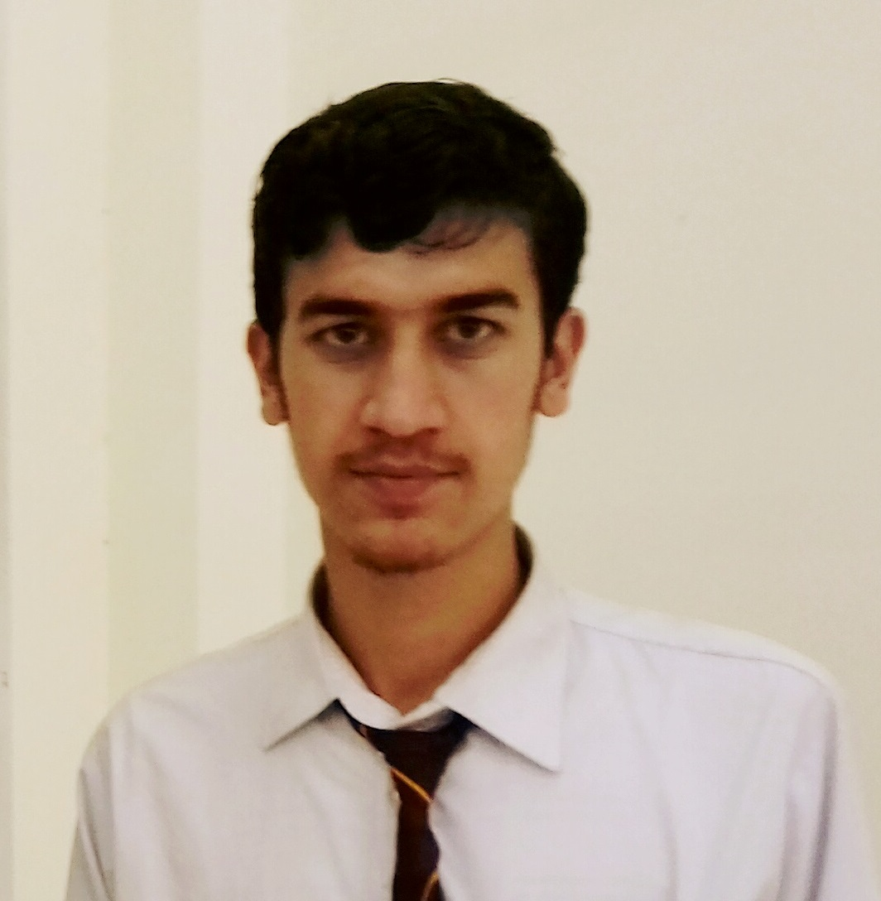

Shabqadar haleemzai district charsadda

Email: zakriakhan092@gmail.com

Cell: 0342- 9869542

**OBJECTIVE:**

To enhance any knowledge and capabilities by working in a dynamic organization that prides itself in giving substantial responsibility to new talent.

**PERSONAL INFORMATION:**

* Father ,s Name ; Riaz khan
* Date of birth ; 13-03-1997
* Cnic No ; 17101-7978487-9
* Religion ; Islam
* Domicile ; Mohmand Agency (FATA)
* Nationality ; Pakistani
* Material Status ; single

**QUALIFICATION:**

|  |  |  |
| --- | --- | --- |
| Matric | Science public school | 80.66 % |
| Intermediate | Govt College Peshawar | 73.09 % |
| Bsc Chemical Engineering | Wah Engineering College (UW) | 68.75 |

**OTHER SKILLS:**

A better Command on MS Office, MS power point, MS Excel And other computer Installation softwares

**HOBBIES:**

* Use Computer
* Reading News paper
* Reading Books

**Language:**

* Urdu
* English
* Pashto

**References:**

**Engr Kamran Alam Cell# 03444523148**

**Engr Kalim Ullah Cell# 03339869894**