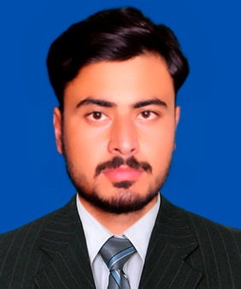

**ADDRESS:**

House#G9 Government Colony Near Women Police Station Astore Post Office Eidgha Tehsil District Astore (GB), Pakistan.

# Hafeez Ur Rehman

**CONTACT:**

Cell: +92-3155113964

Email:hafeezkhan372@gmail.com

CV

**CAREER OBJECTIVE:**

* To grow in a progressive organization, where the blend of my experience and enhanced educational skills can help in achieving the goals of the company. I would like to exploit my potential and sense of obligation for the benefit of the organization.

**EDUCATION:**

|  |
| --- |
| **BE.ELECTRIVAL (ELECTRONICS). ENGG. (Session 2013-17):** |
| **From: Hamdard University of Engineering & Technology , Karachi (Islamabad campus) ------- -- 2.98 CGPA**  **PEC # ELECT/66738** |
| **F.Sc. (Session 2011-13):** |
| **From: Punjab College Of Information Technology S/Town Commercial Market Rawalpindi - - - - 66.54%** |

**FINAL YEAR PROJECT:**

**Smart BTS.** Line of sight will be automatically aligned through the microcontroller.

**PRACTICAL EXPOSURE:**

One Month Training in Pearl Continental Hotel Power Plant Rawalpindi Pakistan.

* **Semesters projects**
* Ups , fire alarm , Stop Watch , amplifier , smart charger , water level indicator arduino based rpm counter , line follower robot and also some other interesting projects.

MATlab based projects of DSP, LCS ,DCS , DIP and CCNET project

* + Instrumentation

**INTERESTS:**

**MAJOR COURSES STUDIED :**

* + Control System
  + Electrical Machines

**PROFESSIONALSKILLS:**

* Experience in handling electrical testing equipment, like multi-meter and oscilloscope, and how to use these skills in problem solving applications.
* Expert in the use of basic hand tools, soldering tools and other electronic assembly tools.
* Image processing and pixels measurement’s.
* MATLAB, , Micro wind, Proteus, Circuit maker, Simulink.
* **MAJOR COURSES STUDIES:**
* Computer Communications & Networking .
* Basic Electrical Engineering.
* Electrical Machine.
* Power Electronic &Engineering Machines .
* Microprocessor and Integrating Circuits.
* Linear control system & Digital control system.
* Power Engineering & EMFT.
* PLC(Programmable Logic Control).

**PERSONAL DETAILS:**

* **Father’s Name:** Muhammad Ashraf
* **Marital Status:** Single.
* **Domicile:** Astore,Gilgit Baltistan
* **Nationality:** Pakistani.
* **Date of Birth**: 12-03-1995.
* **CNIC #:** 71201-2858071-3.
* **Religion:** ISLAM.

**REFERENCES:**

**Engr. Humayun Sulahuddin**

Lecturer, Hamdard University Islamabad Campus

Islamabad, Pakistan. Email: [humayunsalahuddin@gmail.com](mailto:humayunsalahuddin@gmail.com)

**Engr. Saad Rashid**

Lab Engineer, Hamdard University Islamabad Campus

Islamabad, Pakistan. Email: [saadrashid2010@gmail.com](mailto:saadrashid2010@gmail.com)