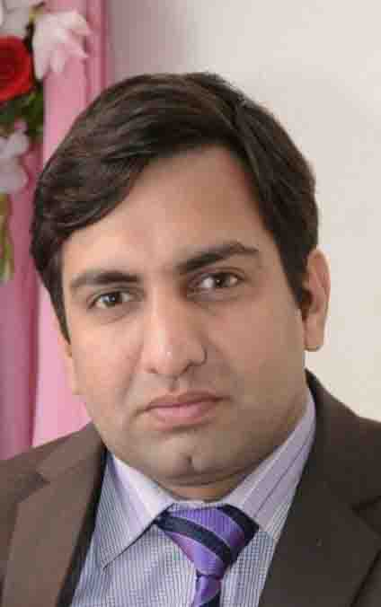

**Objective:**

*“I have great opportunity of a challenging position with a progressive company where I will use my knowledge and experience to learn new things and implement them through procedures, activities, techniques to meet deadlines.”*

***RAHEEL RAUF***

**Education:**

**B.E Chemical Engineering. 2010 University of Engineering & Technology Peshawar**

**H.S.S.C (Pre Engineering). 2006 Hazara Public School and College. (B.I.S.E Abbottabad)**

**S.S.C (Science). 2004 Telecom Boys Public School. (B.I.S.E Abbottabad)**

**Experience:**

**Territory Officer. (August.2014- Dec-2017) Unilever Walls Pakistan**

**Job Description:**

* Work as team leader; manage different routes (local and outstations).
* Manage Market Visits, sort out Market issues.
* Resolve all kind of visibility issues.
* Motivate team to reach their goal and achieve targets motivationally.
* Tackle all kinds of I.T issues in absence of D.P.O(Data processing officer).
* Supervise and resolve all kind of logistics issues.
* Work Honestly, Sincerely, truly showing example to R.S. O’s.
* Manage Damage and Assets issues.

**Production Engineer. (Nov-2011 ~to~ May-2014) Suraj Fertilizers PVT Ltd.**

**Job Description:**

* Reporting plant manager to daily production and activities.
* Supervising and handling all the Process/operations activities at plant.
* To operate the plant efficiently within a varying range of load conditions.
* Monitoring of plant parameters, evaluating and providing recommendation for betterment of process.
* Awareness and positive attitude towards implementation of Advance process control system.
* Engineering assistance to operation and maintenance on technical aspect of the operation, process, procedures & equipment’s.
* Provide Basic engineering to plant modifications and improvements.
* Technical evaluation, HAZOP study, F&G system and selection of equipment meeting Engineering standards.

**Trainee Engineer. (November-2010 ~to~ october-2011) Descon Engineering**

**Job Description:**

* Decide how best to use a plant’s workers and equipment to meet production goals & Analyze production data.
* Create ways to make the production process more efficient.
* Supervising and handling all the Process/operations activities at plant.
* Reporting plant manager to daily production and activities.

**Internships:**

* **Bestway Cement Hattar, Haripur. (17. June.2008 – 16. July.2008)**

Working of Crusher & stacker, Raw material transport, working of rotatory kiln, working of raw mill, Preheaters, cooler, cement mill or ball mill, packing etc.

* **Wah Nobel Acetates Hattar, Haripur. (22. June.2009 – 20. August.2009)**

Working of heat exchangers, cooling towers, filters, working of evaporators, different types of pumps, absorption tower, reboiler, separator, oxidation tower, condenser and process of manufacturing Acetic acid etc.

* **Pakistan Ordnance Factories Wah Cantt.** **(10. August.2010 – 06. September.2010)**

Working of bleacher, centrifuge, narrator, manufacturing explosives, NAC /SAC plants, All metallurgical labs, central testing labs, control labs & machines etc.

**Certification:**

* **Diploma of Master Computer Applications (D.M.C.A) *3 Months. Abacus Computer College***
* **Certified Safety officer.  *2 Months. U.E.T Lahore***



Haripur Hazara

raheelrauf1@gmail.com

D.O.B - 18-January-1987

C.N.I.C - 13302-5594174-7



0995-611490

0304-5905952

**Personal Skills:**

* Leadership skills as well as a team player.
* Planning & implementation skills.
* Excellent organizational & interpersonal skills.
* Scientific approach to decision making process.
* Excellent communication, negotiation skills.
* Resilient, perseverant, hardworking,

enthusiastic &self-confident.

* Understanding the value of honesty, trust &

control in business environment.

**Hobbies:**

* Playing Football.
* Playing Chess.
* Reading Quotes.
* Listening Speeches.
* Yoga.

**IT Skills:**

* MS-Windows 7 ,10, Linux, Unix
* MS-Word, MS-Excel, PowerPoint, MS-Access.
* Cabling & Installing Network, Administrator Networking, TCP/IP Protocol, Home & Office Networking.
* In page, Corel Draw, Adobe CS 6,
* **Urdu (30 wpm)**, **English (65 wpm)**
* Trouble shoot networking and operating system.

**Projects:**

* Design of Spiral Plate Heat Exchanger.
* Analysis of Heat Recovery in Sulphur Acid Plant.

**Self-Accomplishments:**

* Calculation of stream properties & important
* Conversion on MS Excel
* Design of heat exchangers on MS Excel
* Design of heat exchangers on Hysys

**References:**

Available on demand.

**Information:**