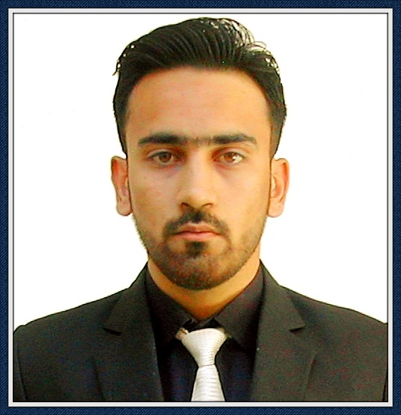**MUHAMMAD SOHAIB**

**B.E (ELECTRICAL ENGINEER)**

**Tel :** 0335-9091131 (**PAKISTAN**)

**E-mail** :Engrsohaib2k13@yahoo.com

**OBJECTIVE:**

* Seeking job of an Electrical Engineer position in an organization where I can apply my skills, loyalty and commitments in exchange for career guidance, training an opportunity for advancements /self-growth.
* Team Player with a strong desire to play my part where needed and express my opinion where required.

**EDUCATION:**

|  |  |
| --- | --- |
| **B.E Electrical Engineering** | **2013-2017** |

UNIVERSITY OF ENGINEERING AND TECHNOLOGY TAXILA

|  |  |
| --- | --- |
| **F.Sc Pre-Engineering** | **2011- 2013** |
| PESHAWAR MODEL DEGREE COLLEGE PESHAWAR |  |
| **Matric** | **2011** |
| PESHAWAR MODEL SCHOOL PESHAWAR |  |

**EXPERIENCE: ( 2 months )**

**(August 2016 to October 2016) (2 months)**

ELECTRICAL TRAINEE ENGINEER

Internship in 132 KV Grid Station Peshawar City

**FINAL YEAR PROJECT:**

“SPEED SYNCHRONIZATION OF BLDC MOTOR USING WIRE-LESS TECHNOLOGY”

**TECHNICAL SKILLS:**

Proficient or familiar with a vast array of software, concepts and technologies, including:

**Engineering Software:**

* Primavera P6
* Cost & Estimation & Quantity Survey
* Electrical Design AutoCAD
* PLC
* MAT LAB
* Keil & Proteus

**Operating Systems:**

* Extensive knowledge and experience with Microsoft Windows (XP, 2000, vista, 7, 8, 10).

**Others:**

* MS Office.
* Internet.

**LANGUAGES:**

**ENGLISH** (FLUENT), **URDU** (FLUENT), **PASHTO** (NATIVE).

I also have strong interpersonal and communication skills.

|  |  |  |
| --- | --- | --- |
| **PERSONAL BIO DATA:** | |  |
| Name | : | Muhammad Sohaib |
| Father’s Name | : | Attaullah Jan |
| Date of Birth | : | 20-March-1995 |
| Marital Status | : | Single |
| Nationality | : | Pakistani |

**REFRENCES**