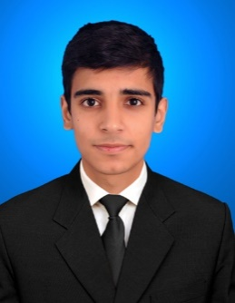

**Saqib Hussain**

**Residential Address***: Block# 48-C, Flat# 4, Sector G-10/3, Islamabad, Pakistan.*

**Contact Number**: *+923065221772*

[saqibhussain279@gmail.com](mailto:Hassan_8921@hotmail.com)

**PROFILE**

To ensure challenging position in a growing organization where I would be able to utilize my capabilities to the best extend and, in the process, add value to the organization and my career.

**EDUCATION AND QUALIFICATIONS**

|  |  |  |  |
| --- | --- | --- | --- |
| **Qualification** | **Institution** | **Marks/CGPA** | **Year** |
| **BSc  Mechanical Engineering** | **University of Engineering and Technology Peshawar, Pakistan.** | **3.02/4.00** | **2014-2018** |
| **Pre- Engineering** | **Islamabad Model College for Boys G-10/4, Islamabad.** | **888/1100** | **2012-2014** |
| **Matric** | **Islamabad Model College for Boys**  **G-10/4, Islamabad.** | **922/1050** | **2010-2012** |

**PERSONAL DETAILS**

|  |
| --- |
| * Father’s Name: **Abid Hussain** |
| * Country of Birth: **Pakistan** |
| * Domicile:  **Astor** |
| * Date of Birth: **30-01-1997** |
| * Gender:  **Male** |
| * CNIC: **61101-5199566-3** |
| * Marital Status: **Single** |
| * Medically: **Fit** |

**final year project**

**Condition Monitoring and Control of Rotor During Vibrations Using MATLAB.**

**Components: -**

* Variable Frequency Drive
* AC Motor
* Shafts
* Ball Bearings

**Internship**

* Worked at Technicon Enterprises on Boiler Maintenance and Daily Inspection.
* Worked as a Trainee Engineer from 5th June 2017 to 31st October 2017 at Technicon Enterprises.

**Professional Skills**

* **MS Office**
* **AutoCAD**
* **Pro E**
* **C++**
* **Adobe Photoshop**

**LEADERSHIP AND MANAGEMENT SKILLS**

**ASHRAE, UET PESHAWAR**

International Member

|  |  |  |
| --- | --- | --- |
| Active member of American Society of Heating Refrigeration and Air Conditioning Engineers.  **American Society of Mechanical Engineers UET Peshawar**   |  |  | | --- | --- | | Participated in 1st Intra UET Wonder Bridge Contest. |  |   **Step up Youth**  Led the event organizing team sponsored by ASHRAE. |