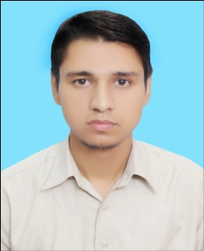**Muhammad Tahir Ayub**

**Address:** H # KH-457, St 15, Model Colony Khana Kak Main Akbar Street near Bank Ground P.O Raja Town Shamabad, Rawalpindi.

**E-Mail-ID:** [tahir.ayub83@gmail.com](mailto:tahir.ayub83@gmail.com)

**Contact #:** 0302-5246790, 0304-3146195

**Objective**

To be a career man and professionally contribute positively in the prosperity and progress of the organization. Furthermore, to serve the nation with specialized and technical skills gained so far.

**Personal Information**

Father Name Muhammad Ayyub

CNIC No. 37405-9204650-5

D.O.B 27-11-1990

Nationality Pakistani

Religion Islam

Marital Status Single

**Academic Information Years of Completion**

**Bachelor in Civil Engineering Technology (2015-2019)**

(Swedish College of Engineering and Technology Rawalpindi)

**Intermediate in Computer Science (2008-2010)**

(Punjab College of Information Technology)

**Matriculation (2006-2008)**

(Al-Ahmed Public Sec. School & College Rawalpindi)

**Skills**

* MS Office (Word, Power Point, Excel)
* Internet Surfing
* AutoCAD (2D,3D)
* Quantity Surveying
* C Programming

**Experience**

* 02 years **“Quantity Surveying”** Experience in Bahria Enclave Islamabad.
* 05 year teaching Experience as a **“Home Tutor”** in Different Areas of Rwp/Isb.

**Hobbies**

* Reading Islamic Books
* Playing Cricket
* Playing Badminton

**Languages**

* Urdu
* English
* Punjabi

**Reference**

* Will be providing on demand.