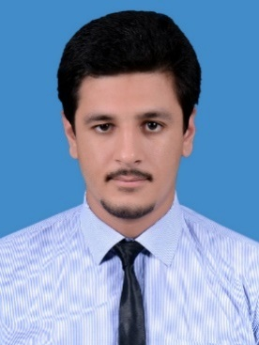**Saad Ahmed**

Lahore, Pakistan.

+92-3338788410

[saadahmed6000@gmail.com](mailto:saadahmed6000@gmail.com)

<https://www.linkedin.com/in/saad-ahmed-632426b9>

# Mechanical Engineer

A passionate and performance driven mechanical engineer who is always up for new challenges. Always fascinated and curious about new technological breakthroughs. I enjoy leading, motivating and collaborating with others.

# Education

|  |  |  |  |
| --- | --- | --- | --- |
| **Qualification** | **Institution** | **Year** | **Marks** |
| B.Sc. Mechanical Engineering | University of Lahore (UOL) | 2013-17 | 3.66/4.0 (CGPA) |
| High School (A Level) | Beaconhouse School System | 2010-12 | 860/1100 |

# Professional Experience

* Nishat Mills Ltd

Trainee Engineer (Operations & Maintenance) May 2018 – August 2018

* Oil and Gas Development Company Limited (OGDCL)  
  Dakhni Gas Processing Plant

Engineering Intern June 2016 - July 2016

* Condition monitoring the parameters of machinery covering data collection, analysis, suggestions and recommendations.
* Carrying out routine scheduled maintenance work and responding to equipment fault.
* Packaging Solutions (PackSol)

Engineering Intern August 2015 - September 2015

* Performed Quality tests on Kraft paper and corrugated cardboard under Technical Association of the Pulp and Paper Industry (TAPPI) Standards.
* Implementation the standards for corrugated fluting medium.
* Shutdown of corrugation unit & coal powered fire tube boiler.

# Projects

* Enhancing performance of a single cylinder spark ignition engine through forced induction.
* Design of energy efficient house.

# Professional Affiliations

* Registered Engineer, Pakistan Engineering Council (PEC) License No: MECH/36573
* Member, American Society of Mechanical Engineers (ASME)

# Skills & Competences Problem Solving, Creativity, Teamwork, Time Management, Microsoft Office Suite, Computer Aided Design (CAD), SolidWorks, Total Productive Maintenance (TPM)

# Languages

Urdu, British English