# ***CURRICULUM VITAE***

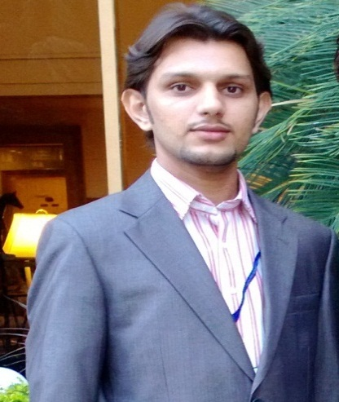

*Subject:* ***APPLICATION FOR JOB***

*Dear Sir,*

*I have attached my Resume. I will be highly grateful to you for considering my CV and giving me an opportunity to work for your institute. I will be thankful for your humble response.*

*Thanking you,*

*Yours Sincerely,*

*(****ENGR. FAIZAN ASHRAF KHAN****)*

*Encl: C.V.*

CURRICULUM VITAE

**FAIZAN ASHRAF KHAN**

**Address:** ِB-657 Malir Colony Karachi

**Mobile No: 0334-3542529**

**Email Address:** faizanashrafkhan1991@gmail.com

**Career Objective**

* To work in a progressive environment with better opportunities and career growth where I could effectively use my educational and professional experience and interpersonal skills.

**Personal Information**

Father Name : Khursheed Ahmed Khan

Date of Birth : 31st March, 1991

C.N.I.C : 42501-7754657-7

Language : English & Urdu

Nationality : Pakistani

Religion : Islam

Marital Status : Single

**Academic Education**

|  |  |
| --- | --- |
| **Degree/Certificates** | **Institute / Board** |
| **Matriculation (Science)** | Board of Secondary Education, Karachi. |
| **Intermediate (Science)** | Board of Intermediate Education, Karachi. |
| **B.E in Energy & Environment** | Dawood University Of Engineering And Technology, Karachi. |
| **M.E in Renewable Engineering (Mechanical Department)** | NED University Of Engineering And technology, Karachi. |
| **NEBOSH IGC** | UK Certified |

**Experience**

* Lecturer at Gov. Poly Technical Institute Landhi from 2017-Present.
* Total Experience of HSE Field 5-6 years.
* Working in **SITARA CHEMICAL INDUSTRIAL LIMITED** at **COAL FIRED POWER PLANT** as **HSE ENGINEER** from 2015 to 2017.

Key Responsibilities:

* Development of the Project Health, Safety and Environmental policies and objectives
* Development of Health, Safety and Environmental key implementation strategies
* Development and implementation of a Project Health, Safety and Environmental Manuals and/or Health, Safety and Environmental Plans (as applicable)
* Development and implementation of Health, Safety and Environmental Training and Orientation programs
* Development of specific Health, Safety and Environmental Work Instructions as needed.
* Development of Health, Safety and Environmental System Document Register
* Development and implementation of Nonconformance, Corrective, and Preventive Action process.
* Development and implementation of Health, Safety and Environmental auditing processes (involving assessment of all project groups)
* Promotion of Health, Safety and Environmental awareness throughout organization
* Responsible for assessing work load, developing staffing plans, and recruitment of Health, Safety and Environmental team members when needed.
* Providing direction to all health, Safety and Environmental Personnel.
* Promotion of Health, Safety and Environmental awareness to subordinates
* Commissioned Firefighting system and alarming system.
* Provide positive suggestions to Management for the betterment of HSE system.
* Worked as **HSE ENGINEER** at International Fashion Apparel, Having two years of experience.
* Worked as **Project Coordinator**.
* Worked in the project of Biogas Plant and Waste Disposal Plant by PCSIR.
* Have Sound Knowledge on **Renewable Energy** Resources.

**Jilani Flexible Packages**

* I worked in JFP in Quality Control Department as a Trainee Engineer.

**Responsibilities:**

* To check Quality of Plastic Films as Per Standards.
* To Maintain And Update The Documentation Of The Q.C Lab.
* To Maintain the House Keeping in Q.C lab As per Management Instructions.
* To Discuss The Top Management For The Continual Improvement For Our Product.
* Have Knowledge about Plastic Material Like **LDPE, LLDPE & HDPE**.

**Internship**

* PCSIR
* International Fashion Apparel as HSE officer

**Others Skills**

* C.I.T (MS Office)
* Waste Water Analysis, Solid Waste Analysis & Composting techniques.
* Fabricated **“COAL GASIFICATION PLANT”** as my final year project. The Object Is To Obtain “SYNGAS” From Thar Coal, Gin Waste, Rice Husk & Bagasse. SYNGAS can be used as substitute of natural gas.
* Also worked on **Wind Mills and Hydro Power System**.

**Visits**

* GSK (GlaxoSmithKline).
* Pakistan Cables Ltd.