Muhammad Arshad

Address- B946 Steel Town Karachi

Address 2: Vill: Waryo Wahan Taluka Gambat Distt: Khairpur Mir’s

**(+92)3013506430**

Email: [**arshad_ayoub24@outlook.com**](mailto:arshad_ayoub24@outlook.com)

**Ready to relocate anywhere for a suitable opportunity**

OBJECTIVES

To serve in an organization offering job satisfaction, challenging accounting goals and vast opportunities of career building.

PERSONAL INFO

|  |  |  |
| --- | --- | --- |
| o | Name: | Muhammad Arshad. |
| o | Father’s Name: | Muhammad Ayoub. |
| o | Surname: | Junejo. |
| o | Date of Birth: | August 27, 1995. |
| o | CNIC No: | 45202-6841929-5. |
| o | Domicile: | Khairpur Mir’s. |
| o | Nationality: | Pakistani. |
| o | Religion: | Islam. |
| o | Marital Status: | Single. |

QUALIFICATIONS

* Bachelor of Engineering.

In the department of ***Electrical Engineering***.

Mehran University of Engineering and Technology SZAB Khairpur Mir’s

1st Division, 72.08%, CGPA 2.87 (2014-2017)

* INTERMEDIATE (A+)

BISE Sukkur 2011-13.

* MATRICULATION (topper)

BISE Sukkur 2009-11.

A DAY OF MY LIFE

LIFE PHILOSOPHY

*“Never Give up.”*

MOST PROUD OF

Perfect understanding of

Fundamental Electrical Engineering concepts with extraordinary ability to apply them in a varied manner.

Excellent Communication &

Comprehension Skills.

Persistence & Loyalty

Willingness to stay with an efficient organization.

Confident & Empathetic

Attitude towards team personnel.

STRENGTHS

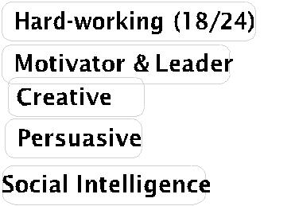

ADDITIONAL SKILLS

Spending time with family.

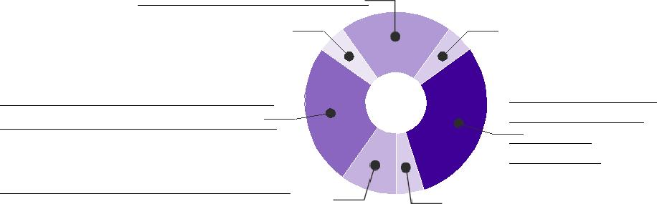

Spiritual activities - Offering

Namaz & Reciting holy book.

Avid reader of contemporary

affairs & recent advances in

science & technology.

Sleeping & dreaming about Doing

More in my life

Internet Surfing i.e. looking for

research programs.

Study related to my field

.

Listening to news & talk

shows.

**Proficiency in English**

**Certified from Mehran University**

**Professional Softwares**

MS Word

Have worked on MATlab

Have worked on Multisim

Have worked on Arduino

**Basic computer skills**

Internet surfing: Engineering practices, exploring various aspects of Electrical Engineering.

Good at handling MS-Office and delivering quality based presentations.

KEY ACHIEVEMENTS

**Professional:**

* ***Intern***

WAPDA TR(D) workshop Sukkur

(june 2017- july 2017

* Successfully made Solar Tracking system.

**Academic**

* 2x PM Laptop Scheme Winner
* Board Topper in Matriculation
* Class topper in Intermediate.

**Extra curricular**

* Successfully organized three days Mega Event “Hi Tech Students’ Electro week” in 2017 at Mehran University of Engineering and Technology SZAB Khairpur Mir’s.
* Organized FunDay Fiesta Event in 2016 at Mehran University.
* Main of the tournament in “Cricket tournament 2017” at Mehran university.

FUTURE PLANS

* To be the best at what I do.
* Carrying out periodic risk analysis about various decisions of the company particularly regarding Electrical Engineering.
* Interested in realistic work and believe in hands on job experience,

PROJECTS

* Solar tracking System (2017)
* Model of Electrical Power Supply system
* Audio Amplifier

Industrial visits

* Pakistan Cables was visited, an overview of the industry was given.
* Zorllu Power plant.
* NTDC 500KV Guddu.

LANGUAGES

|  |  |
| --- | --- |
| Urdu | ○ ○ ○ ○ ○ |
| English | ○ ○ ○ ○ ○ |
| Sindhi | ○ ○ ○ ○ ○ |
| Chinese | ○ ○ ○ ○ ○ |
| Punjabi | ○ ○ ○ ○ ○ |

References

.

Will be furnished upon request.