**Muhammad Rashid** 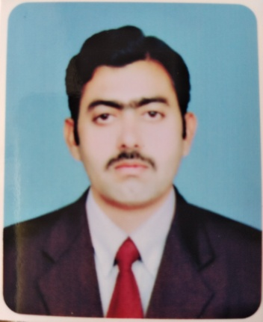

**Electrical Engineer**

**Nationality:** Pakistani

**Contact**: +92-3076547246

**Mail ID:** [Muhammadrashid875@yahoo.com](mailto:Muhammadrashid875@yahoo.com)

**Skype ID:**  rashidjahanian

Jahanian, Pakistan

**Objective:**

To obtain a challenging position in a progressive organization where I can contribute towards the aims of organization and develop my skills by working with a team of dedicated and experienced engineers and professionals.

**Summary:**

* Graduate with BS in Electrical Engineering

**Education:**

* **B.Sc. Electrical Engineering** (2010-2014)

**University of Engineering & Technology Lahore** (CGPA: 3.036/4.0)

* **F.Sc. (Pre-Engineering)** (2008-2010)

**Superior science higher secondary school Khanewal** (Marks: 906/1100)

* **Matric** (2006-2008)

**Govt. high school Jahanian** (Marks: 685/850)

**Key Skills:**

* Project management, reconciling problems and leadership qualities, Team work and Quick Learner, Flexible and reliable.
* Capability to work in very sensitive environment and to lead the operation.
* Having ability of critical thinking and complex problem solving.
* Possessing an excellent team spirit and capable of interacting effectively with other discipline professionals.
* Excellent communication skills and fluent in English, Urdu, Punjabi.

**Certificate:**

Pakistan Engineering council (PEC) number is Elect/48304

**References:**

**References will be provided on demand**