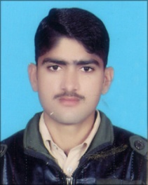

***MUHAMMAD RIZWAN***

*Cell No:0304-0072771*

*Address: Chak No.771 GB Tehsil Pirmahal District Toba Tek Singh.*

***OBJECTIVE***

To work in an organization where my knowledge and experts could be used for the prosperity and growth of the organization..

***PERSONAL DETAIL,S***

* Father,s Name: Ghulam Rasool
* Date of Birth: 01-01-1999
* CNIC No: 33302-1108552-7
* Marital Status: Single
* Religion: Islam
* Nationality: Pakistani

Cell No. 0348 7606267

***ACADMIC QUALIFICATION***

|  |  |  |  |
| --- | --- | --- | --- |
| **Degree** | **Year** | **Board/Institute** | **Marks** |
| DAE (Mechanical) | 2018 | PBTE Lahore | 2607/3450 |
| Metric | 2015 | B.I.S.E Faisalabad | 625/1100 |

***COMPUTER SKILLS***

Basic Knowledge of Computer

Internet & Email

***EXPERIENCE***

Fresh

**.**

***REFRENCE***

**Will Be Furnished On Demand.**