# OBJECTIVES

I am seeking a challenging career that utilizes my skills and abilities and provide an opportunity to work in a professional environment. I solemnly believe in hard work and devotion and hence, offer my services to the best of my capabilities.

# PERSONAL INFORMATION

Name: **ASIF ULLAH**

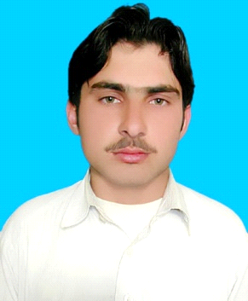

Father Name: **WAHEED ULLAH**

Date of Birth: 12-03-1996

Gender Male

Religion: Islam

Domicile: Charsadda

Marital Status: Single

Nationality: Pakistani

CNIC No. 17101-2917648-5

Email Address: [asifullah56@yahoo.com](mailto:asifullah56@yahoo.com)

Contact No: +92-332-9607669 & 0304-5275716

Permanent Address: Village Haji Abad P/O Matta Mughal Khel, TehsilShabqadar

District Charsadda Khyber Pakhtunkhwa Pakistan.

# EDUCATION PROFILE

|  |  |  |  |
| --- | --- | --- | --- |
| Degree / Certificate | Institution/Board | Session | Marks |
| S.S.C (Science) | BISE Peshawar | 2011 | 790/1050 |
| DAE (Chemical) | BTE Peshawar | 2014 | 2350/3400 |
| BS Chemistry (specialization Applied chemistry) | Bacha Khan University Charsadda | 2014-2018 | 3.0CGPA |

# COMPUTER SKILL:

# 

**Operating Systems:**

Windows 98, Windows Xp,

**Microsoft Office:**

* Ms. Word, Ms. Excel, Ms. Access, Ms. Power Point

**Typing speed:**20-30Wpm

**OTHER SKILLS:**

Team Work & Time Management, and Problem Solving & Management of events

**INTERPERSONAL SKILLS:**

Good Communication, Problem Solver, Self-Motivated, Innovative thinker, Decision making, Multi-tasking, Public presentation skills, Curriculum awareness, Planning & Scheduling

**FINAL YEAR PROJECT:**

One year research work experience on preparation of Fe-Mn/poly(methylmethacrylate)Nylon 6,6 Ternary blend

1. **FTIR(** Fourier-transform infrared spectroscopy)
2. **TGA**
3. **UV spectrometry**

**Reference:**

**Dr.Khalid saeed Sir**

**Chairman Department of chemistry**

**At bacha khan university charsadda kpk Pakistan**

**Email:Khalidkhalil2002@yahoo.com**

**Phone no:03239290054**

# COMMUNICATION LANGUAGE READING WRITE SPEAKS

|  |  |  |  |
| --- | --- | --- | --- |
| Pashto | Excellent | Excellent | Fluent |
| English | Excellent | Excellent | Good |
| Urdu | Excellent | Excellent | Excellent |