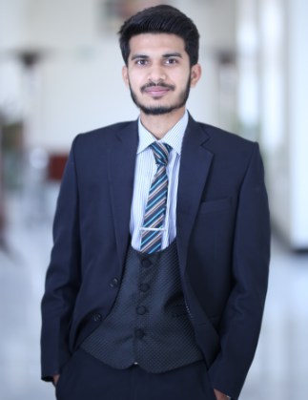

Aiez Nazir

**Chemical Engineer**

I am passionate about exploring new ideas and options to tackle

Challenges posed within our surroundings. I combine my passion with

Meticulous work and research to ensure the best possible outcome.

­­­­­­­­­­­­

# Internship

**Olympia Chemicals Limited**

06/2016 - 07/2016 Warcha, Mianwalli

**Pakistan’s Largest Caustic Soda Producing Company**

**Tasks/Achievements**

* Got Training of the whole process.
* Got the idea of coal based power plant.
* Played key role in understanding of boilers.

# Internship

**General Electric, O&M, Saif power limited.**

07/2017 - 08/2017 -Qadirabad, Sahiwal.

**225MW power plant**

**Tasks/Achievements**

* Got Training of the whole process.
* Got the idea of combined cyclepower plant.
* Got the knowledge of Gas and steam turbine.

# Personal Projects

* Conversion of Biomass to Biochemical.

5th semester Project

* Worked with my team in making a Charcoal from different resources of biomass available,

Semester Project

* Community Service: Organized Career Counseling Sessions at different Schools.
* FYP Modified production of Hydrogen by Steam methane membrane reforming.

# Education

## Secondary School Education (SSC)

Falcon Public School

2011 - 2012 -Okara

## Higher Secondary School Education (HSSC)

Suffa College

2012 - 2014 -Okara

**BS Chemical Engineering**

Department of Chemical Engineering, University of Gujrat, Gujrat.

2014 2018 - Gujrat

Courses

* Chemical Process Technology.
* Thermodynamics.
* Chemical Reaction Engineering.
* Mass Transfer.
* Simultaneous Heat and mass transfer.

# Skills & Competences

* Mat lab
* Microsoft Visio
* MS-Office
* CHEMCHAD

# Achievements

* Executive member UOG Debating Society. (2015 - 2016)
* Participated in International Conference on Emerging Science and technology.
* Winner of power house competition in GIKI.
* Project Club head at CHESS University of Gujrat.