|  |
| --- |
| Personal profile: |

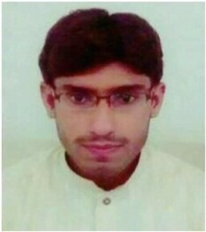Curriculam vitae

Name : Waqar Hassan Father,s Name : Abdul Jabbar Date of birth : 10-02-1996 C.N.I.C # : 36502-2720739-5 Religion : Islam Merital status : Single Nationality : Pakistani Domicile : Sahiwal (Punjab) Address : Mohalla Zargran Ward. #8 Kameer 120/9-l Teh/District Sahiwal Mob.# : 03237592108

Email Address : waqarwt50@gmail.com

|  |
| --- |
| Educational Record: |

|  |  |  |  |  |
| --- | --- | --- | --- | --- |
| Cours | Year | Marks | Division | Board/ University |
| B.A | 2015 | 471/800 | 2nd | BZU. Multan |
| Fs.c | 2013 | 722/1100 | 1st | B.I.S.E. Sahiwal |
| Matric | 2011 | 932/1050 | 1st | B.I.S.E. Multan |
|  |  | | | |

|  |
| --- |
| Experience: |

Working as a voyage operator at coke distribution

|  |
| --- |
| Skill: |

Computer Programme : MS Office, Inpage, Coral draw