R E S U M E

|  |
| --- |
| **Muhammad Jabbar** |

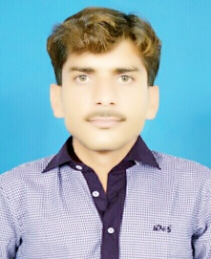

**Mobile No:** 0305-7430867

**Email :** jabbarbhatti566@gmail.com

**Address :** Cheema Colony, Near Imam Bargah, Village & P.O Dharema, Tehsil & District Sargodha.

|  |
| --- |
| **Personal Information:** |

**Father Name :** Khizar Hayat

**Date of Birth :** 05-04-1998

**CNIC No :** 38404-2216063-7

**Religion** **:** Islam

**Marital Status :** Single

**Domicile :** Sargodha-Punjab

|  |
| --- |
| **Objectives:** |

* To get a chance of working in an institution where my education, strong aptitude for learning presentation and abilities would be utilized and I shall have an opportunity to improve it.

|  |
| --- |
| **Academic Qualifications:** |

|  |  |  |  |  |  |  |
| --- | --- | --- | --- | --- | --- | --- |
| **Degree** | **Passing Year** | **Total**  **Marks** | **Obtained Marks** | **Percentage** | **Grade** | **Board** |
| **Matric**  (Science) | 2014 | 1100 | 604 | 55% | C | **BISE** Sargodha |
| **DAE**  (Electronics) | 2017 | 3450 | 2586 | 75% | A | **PBTE** Lahore |

|  |
| --- |
| **Computer Courses:** |

* **4** Months Diploma in **Computer Software** from Islamic Computer and Skills Center
* **8** Months Diploma in **Computer Hardware & Network Professional** from

(Vocational Training institute ,Sargodha)

|  |
| --- |
| **Hobbies:** |

Naat Khawani

Plying Cricket

|  |
| --- |
| **Reference** |

**Will be furnished on demand**