**Muhammad Naveed**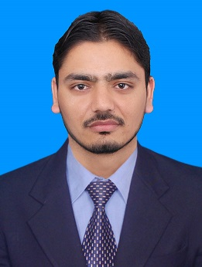

**Chemical Engineer**

**Email Address:** [**mnaveed4251@gmail.com**](mailto:mnaveed4251@gmail.com)

**mnaveed54@outlook.com**

**Contact Number: +92 315 5857677 / +92 345 4735071**

**Father’s Name**: **Muhammad Manzoor**

**Religion**: **Islam**

**NIC**: **13503-7666227-9**

**Nationality: Pakistani**

**Date of Birth: 03 February 1992**

**Address: village Islampur near Kanate P/O box College Doraha, District and Tehsil Mansehra.**

**CAREER OBJECTIVE**

Looking for production and process engineer in industry where I can utilize my knowledge and interpersonal skills.

**KEY SKILLS**

Critical thinking , problem solver , industrious and team player.

**ACADEMIC QUALIFICATIONS**

|  |  |  |  |
| --- | --- | --- | --- |
| B.E in Chemical Engineering | CGPA  3.43 | Dawood University Of Engineering and Technology Karachi. | 2014 to 2018 |
| Intermediate | 720/1100 | Board BISE Abbottabad | 2011 |
| Matric | 802/1050 | Board BISE Abbottabad | 2009 |

**FINAL YEAR PROJCT AND PROJECT EXPERIENCE**

Good experience in final year project **“(Case Study of LPG Recovery From Natural Gas Liquid NGL)”** and also on different equipment such as separator, reboiler, heat exchanger, compressor, de-ethanizer column, de- botanizer column etc at OGDCL kunnar field.

**PROFESSIONAL EXPERIENCE**

Fresh graduate

**COMMUNICATION AND INTERPERSONAL SKILLS**

Competent in communication, interpersonal and negotiation skills

Ability to work as a team member and handle multiple tasks

Good command on English, Urdu and other local languages

**COMPUTER SKILLS**

Good command on: MS Word ,MS Excel, Power Point

Browsing internet and email

Operating windows

**INTEREST AND HOBBIES**

Reading informative course and Islamic books, travelling etc

Watching informative movies

REFERENCE

Available upon request