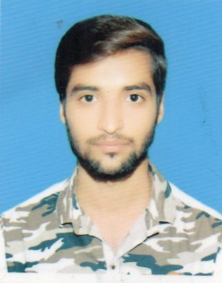**USMAN AHMED**

**S/O Sulman Yousaf**

House No. 6 Al-Imran Street Near AL-Khan Hotel

7KM Sheikhupura Road Shahdara, Lahore

[USMANAHMED241@GMAIL.COM](mailto:USMANAHMED241@GMAIL.COM)

D.O.B 21-AUG-1995

0304-4604056

0335-4604056

**OBJECTIVE:**

Looking for a challenging position in a reputable organization, having attractive environment, friendly atmosphere, and prospects of growth and learning. Being a young and energetic person I can accept the challenges as a Team member and Leader of the Team.

**EDUCATION:**

* Bachelor of Science (B.sc) in Chemical Engineering securing CGPA of 2.979 from University of Engineering & Technology, Lahore
* Intermediate Faculty of Sciences (F.sc Pre-Engineering) in 1st division from Government Islamia College Civil Lines, Lahore
* Matriculation (Science) in 1st division from Kids Galaxy Boys High School Shahdara, Lahore

**PROFESSIONAL COURSE:**

* Advanced System for Process Engineering (ASPEN Plus)

**EXPERIENCE:**

* Five months experience in Sui Northern Gas Pipelines Limited (SNGPL) as Contract Engineer in Metering Department, Domestic Meter Inspection Shop (DMIS)

**DESCRIPTION:**

Following is the job description:

* Ensure inspection of all Domestic Meters received at Domestic Meter Inspection Shop (DMIS).
* Generation of Meter Inspection Reports (MIR) of Domestic Meters in accordance with time lines set by Oil & Gas Regulatory Authority (OGRA).
* Keep updated record of MIRs and of Meter received, checked, pending for checking, scrapped and sent to store.
* Inspection of Meter Seals on daily basis and perform random Flow Proving/Inspection of meters to maintain quality.
* Monitor receipt and dispatch of meters.
* Safe storage of tampered meters.
* Monitor MIR generation, checking and/or signing of MIRs.
* Dispatch MIRs to respective Regional General Managers/In charges and drafting the daily, weekly and monthly reports.
* Make arrangements for audits to be conducted by Central Meter Shop (CMS)
* Ensure in-time calibration of test meters.
* To manage and implement HSE policies and procedures.
* Reasearch and Developments with respect to meters and advanced measurement equipments to reduce gas losses of the Company.

**PROJECTS:**

* **Final Year Project** (Production of Ethylbenzene by Mobil-Badger Process)

Performed material and energy balance on distillation and flash seperator as well as design of the reactor, distillation and heat exchanger.

* **Poster Presentation Project** (Production of Biofuel by Switchgrass)

Detailed study of the process being carried out.

* **Entreprenuer Project** (Cherrys and Berrys Fruit Company)

**COMPUTER SKILLS:**

* ASPEN Plus
* MicroSoft Office (Word, Excel, Powerpoint)
* In-Page Urdu
* Adobe Photoshop
* Basic Knowledge of Computer and IT
* Installation of Windows (XP, 7, 8, 10)

**PERSONEL ATTRIBUTES:**

* Good Communication Skill
* Good Inter-personel Skill
* Self Motivated
* Good Listener
* Responsible

**HOBBIES:**

* Cricket
* Badminton
* Table Tennis
* Ineternet & Movies

**REFERENCE:**

Will be furnished on demand.