**Muhammad Fahid Khan**

**PEC No. 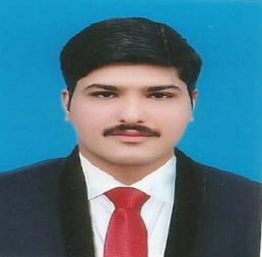# ELECT/59244**

House # 198, Street # 03, GillaniMuhallah

Jaranwala, Faisalabad

[Fahid.khan14@gmail.com](mailto:Fahid.khan14@gmail.com)

+ 92-337-1651816

**Objective**

I want to be an energetic and enthusiastic team member to devote and utilized my best technical skills in order to having the key role in the development and prosperity of that organization.

**Personal Information**

Father’s Name: Rashid Mahmood Khan

Date of Birth: 14 August, 1995

CNIC No.: 33104-1733212-1

Religion: Islam

**Education**

|  |  |  |
| --- | --- | --- |
| 2012—2016 | **B.sc Electrical Engineering** | CGPA 2.8 |
|  | NFC Institute Of Engineering & Fertilizer Research,  Faisalabad |  |
| 2010 --2012 | **F.sc (Pre-Engineering)** | 79.27% |
|  | Punjab College for Science , Jaranwala |  |
| 2008 --2010 | **Matriculation** | 83.23% |
|  | Al-Ejaz High School, Jaranwala |  |

**Personal Skills**

**Management** MS Office

**Software** Proteus,Mat lab

**Languages** C++, C

**Work Experience**

* **Currently doing Job at ITTEHAD TEXTILE GROUP OF INDUSTRIES, Khurianwala: (Since April, 2017)**

I’m currently doing job at Ittehad textile industry khurianwala as a TRAINEE ENGINEER ELECTRICAL. I am gaining knowledge about power generation, load management, load shifting, power factor improvement and running machanism of processing machines and about the control system of machines.

* **4 weeks Internship at NTDC 220 KV Grid Station Jaranwala road , Faisalabad:**  
  Learned about Electrical installation and instrumentation, Protection, Distribution, Testing, Maintenance, SCADA system installation and utilization. I learned how to clear the fault if the hot spot or red spot occurs on the circuit breaker. I learned how to handle the streamer discharge and learned how to reduce the Ferrante effect. I learned how to reduce the skin effect. Usage of bundle conductor and spacing between the conductors. I learned the different types of relays, Auto-recloser, Circuit breaker especially the SF6 CB and Air blast CB. I learned how to maintain the Power Factor on both transmission side and the distribution side and how to compensate the Power factor on consumer factor and what steps are to be taken to avoid from penalty for drop in power factor.

**Hobbies and Languages**

* Cricket, Football, Badminton
* Reading books, History, Gardening  
* Current Affairs    
* Punjabi, Urdu & English

**Area of interest**

* Power generation

#### Power Transmission and Distribution

#### Protection and Instrumentation

* Control System

**Projects**

* **(Final Year Project)**

**Wheelchair Automation using Head Gestures**

* **(Semester Projects)**

Mobile Phone charger

Obstacle avoiding Arduino Robot

Digital Clock

Small DC power supply

**PERSONAL COMPETENCIES**

* Positive Attitude
* Good communication skills
* Ability to grasp whatever information given to me without any hesitation.
* Self-starter, capable of working independently but at the same time I am a team player.
* Able to maintain healthy and cooperative relationship with seniors and colleagues.