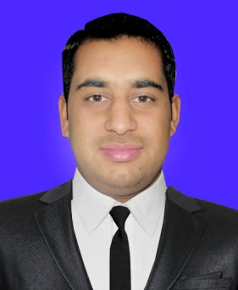**CurriculUm Vitae**

**Muhammad Atif**

**Street ARI P.O. Box #24330 Tarnab Farm District Peshawar**

**Mob: +92 333 9041143(PAK)**

**Email: atif.m76@gmail.com**

|  |
| --- |
| **OBJECTIVE** |

*A position with an organization where I can utilize the best of my skills and abilities that fit to my education, skills and experience a place where an encourage and permitted to be an active participant as well vital contribute on development of the company.*

**Skills:-**

* Efficient and well behaved person
* Very Energetic result oriented and organized
* Ability to work well in terms
* Fast adaptive learner with excellent power to learn

|  |
| --- |
| **EDUCATIONAL QUALIFICATIONS** |

|  |  |  |  |  |  |  |
| --- | --- | --- | --- | --- | --- | --- |
| **CERTIFICATE/DEGREE** | **SUBJECT** | **YEAR OF PASSING** | **OBTAINED MARKS/CGPA** | **TOTAL MARKS/CGPA** | **Division** | **UNIVERSITY/**  **COLLAGE** |
| S.S.C | Science | 2010 | 692 | 1050 | 1st | B.I.S.E Mardan |
| D.A.E | Chemical | 2013 | 2325 | 3400 | 1st | KP.B.T.E Peshawar |
| BS (Hons) | Chemistry | 2017 | 2.91CGPA | 4.00 CGPA | 1st | Abdul Wali Khan University Mardan |

|  |
| --- |
| **COMPUTER SKILLS** |

|  |  |  |  |  |
| --- | --- | --- | --- | --- |
| **CERTIFICATE** | **FROM** | **TO** | **DURATION** | **INSTITUTE** |
| Office Automation | 1st July 2007 | 31 Dec 2007 | 6 Months | SS Computer College Tarnab Farm Peshawar |
| Office Automation | 20 Oct 2010 | 20 Jan 2011 | 3 Months | Communix Institute of IT & Management Sciences Peshawar |
| * **Windows, Inpage, Internet skills, Data Entry Skills** | | | | |

**PROFESSIONAL**

* Ability to maintain composure when exposed to stress.
* Neat and professional appearance.
* Strong work ethic; self-starter; results orientated.
* Able to handle sensitive and confidential situations.

|  |
| --- |
| **PERSONAL INFORMATION** |

Nationality : Pakistan

Father’s Name : Muhammad Wahid

Date of Birth : 15/04/1993

C NIC : 17301-6591146-1

Gender : Male

Religion : Islam

Marital Status : Single

Language Known : English, Urdu, Pashto

|  |
| --- |
| **CHARACTER REFERENCE** |

Available upon request

I hereby and certify that the above mentioned is true and correct to the best of my knowledge and belief.

**Muhammad Atif**