House #7,STREET#5, MIAN MEER village,

UPPER MALL,LAHORE

Mobile nO. 03330442829

E-mail Address: [jahanzeblodhi9@gmail.com](mailto:jahanzeblodhi9@gmail.com)

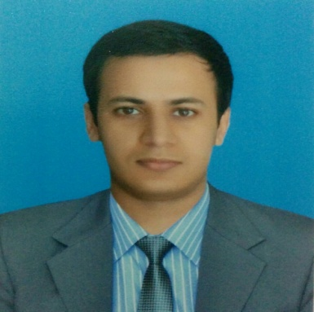

M.Jahanzeb lodhi

OBJECTIVE

*I am currently looking for a full time position in an environment that offers me a greater challenge, increased opportunities along with enhanced leadership qualities, thus helping the company to advance efficiently and productively*.

SUMMARY OF QUALIFICATIONS

[Dates] [Institution Name] [City, State] [Degree]

2017 Virtual University Lahore, Pakistan Masters in

Public

Administration

2010-2015 The University of Lahore Lahore, Pakistan B.Sc. Electrical . Engineering

2008-2010. GOVT. College For Boys Lahore,Pakistan F.Sc.

Gulberg (pre-engineering)

2006-2008 The Educators Bilqees Campus Lahore,Pakistan Matric

EXPERIENCE

* 1 month internship at NTDC (National Transmission & Dispatch company), in protection department of 220KV, 500KV transmission line and grid system.
* 2 years experience as coordinator to principal at The Educators Bilqees campus, Lahore.
* 6 months experience as coordinator at TEC (pvt.) Ltd. Company under PM Youth Internship Program.
* 6 months internship experience at Social Welfare and Bait-ul-mal Department, Town Hall, Lahore under PM Youth Internship Program.

EXTRA-CURRICULAR ACTIVITIES:

* Sports: badminton
* Reading

COMPETENCIES

* Topped in Pakistan in the semesters of MPA degree.
* Registered engineer of Pakistan Engineering Council.
* Have supervisory license awarded by PEC.
* Have broader knowledge regarding current affairs, Pakistan affairs, everyday science, international relations, gender studies, sociology, international law, public administration.
* Strong decision-making skills and the ability to prioritize and plan effectively.
* Ability and also willingness to work in all weather conditions.
* Excellent customer facing and communication skills.
* Negotiating with suppliers and purchase items at optimum cost.

SKILLS

MS office……………………………………Fluent

C++………………………………………… Fluent

Keil uvision………………………………….Fluent

MAT Lab…………………………………….Fluent

SIMULINK………………………………….Fluent

Xilinx ISE……………………………………Fluent

Multisim………………………………..Fluent

PSpice……………………………….....Fluent

Auto CAD………………………………….....Basic

LANGUAGES

English………………………………………..Fluent

Urdu…………………………………………..Fluent

Punjabi………………………………………..Fluent

REFERENCES

Available on request