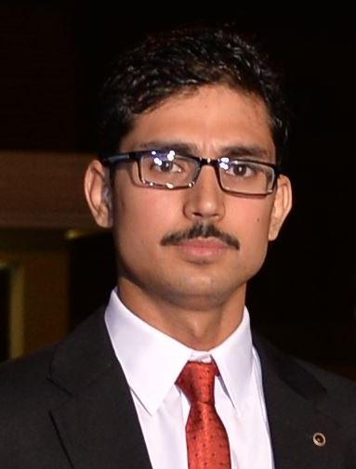**PERSONAL DATA:**

NAME: MUHAMMAD WAQAS

FATHER NAME: MUHAMMAD PERVEZ

CONTACT NUMBER: 0333-5025130

RELIGION: ISLAM

NATIONALITY: PAKISTAN

N.I.C: 13503-6666270-3

ADDRESS: HOUSE#3R, STREET#1, SETHI TOWN, HUSSAIN CHOWK,PEHAWAR

EMAIL:[**waqastoru@hotmail.com**](mailto:waqastoru@hotmail.com)

**SUMMARY:**

A creative and ambitious individual able to work on his own initiative or equally as part of team. Adaptable, efficient and innovative. A creative problem-solver. A person with excellent inter-personal and communications skills. Works effectively in a team. Seeks and finds good outcome to challenges. Ability to work well under strict deadlines and pressure with excellent interpersonal and team skills.

OBJECTIVES:

To obtain a full time position in an organization that offers a professional working environment and enables me as a fresh graduate to grow while meeting the corporation’s goals.

EXPERIENCE AND RESPONSIBILITIES:

Currently working: Mashriq Tv

Joining date: 22-August-2017

Working as “**Transmission Officer”**

I have expertise in Wired and LAN/WAN configuration and administration. Server Administration (windows 7 and XP clients) Planning Active Directory, group policy, IP schema, users/groups/roles deployment. DSL administration and troubleshooting Hardware and software solutions (installation and troubleshooting). Procurement, deployment of IT equipment’s. Inventory Management and Reporting of IT/system equipment. Backup of organization data and installed server backup’s.

PROFESSIONAL SKILLS:

**NETWORK ADMININSTRATION:** Management Configuration & Troubleshooting good grip on TCP/IPLAN/WAN.Versio server management and automation with ADC air client and Media Client. NMS server and NAS.

**NOC**: **Network Operation Center:** DSNG Alignment, carrier firing using KU band, C band transmission, BUC (block up converter) and Encoder settings

**PLATE FORMS:** Windows Server 2012, Windows Server 2008, Windows 2003 server, Windows 2000 Advanced Server, Windows NT Server, Windows XP, Windows NT, Windows 7, Windows 8, Windows 8.1, Windows 10,

**CCTV / IP CAMERAS:** HIKVISION IP Cameras, Troubleshooting & Management, Software Installation, DVR (Digital Video Recorder, DVS (Digital Video Server). NVR (Network Video Recorder) Configuration Trouble shooting & Management.

**SOFTWARE KNOWLEDGE:** Office Automation and most common Microsoft packages, Adobe Photoshop, Microsoft Office, MATLab, PSpice. OTA On the air, Versio ADC Air client.

**HARDWARE:** Assembling, Cabling, and troubleshooting of Systems and Network Devices.

**ANTIVIRUS:** AVG antivirus Symantec Antivirus Server, Kaspersky Antivirus, Avira, Nod32, AVG Antivirus and AVAST Antivirus.

.

EDUCATION:

* University of Engineering Peshawar (UET)

MS Communication & Electronics

CGPA (3.32)

* CECOS University of Engineering Hayatabad, Peshawar.

BE Electrical Engineering

CGPA (2.95).

Year: 2009 - 2013

* Peshawar Model Degree College.

HSSC (Pre-Engineering)

1st Division 77.8 %

* Peshawar Model School (Boys III)

SSC (Science)

1st Division 78%

**FINAL YEAR PROJECT:**

Electricity generation from solid waste garbage.

LANGUAGES:

* Urdu.
* English.
* Hindko.
* Pashto

**REFERENCES**: To be had on demand.