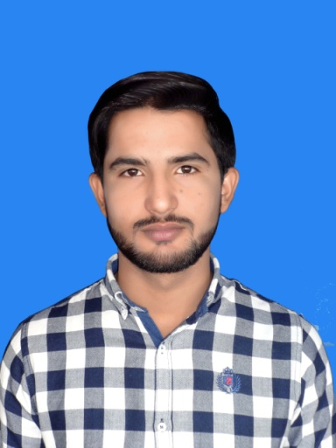

Father Name

Domicile

CNIC

Religion

**Tariq Aziz**

**Bahawalnagar Punjab**

**31104-4821804-7**

**Muslim**

**CNIC**

**Personal Info**

Obtained marks 791

Total Marks 1050

Percentage 75%

**Govet College Of Technology Multan**

**2013- 2016**

ZEESHAN TARIQ

(DAE Chemical)

Azeem Town faqirwali Tehsil Haroonabad Dist Bahawalnagar

+92-304-9981592

Zeeshan.tariq96@gmail.com

**Experience**

**Reference**

**Plant Operator**

**DAE Chemical**

**Matriculation**

**Skills**

2 Years experience in International Electroplating Pvt Ltd as a Plant operator .

**To work to the best of my abilities in an environment that facilitates learning and encourages good performance.**

Obtained Marks 2608

Total Marks 3400

Percentage 77%

MS Office

Leadership

Problem Solving

Networking

**IEL pvt Ltd**

**Objective**

**Faqirwali Science School**

**2011-2013**

**Mr. Ghulam Murtaza**

Business Tycoon

**Hafiz Muhammad Amin**

Govet Employee

**Education**