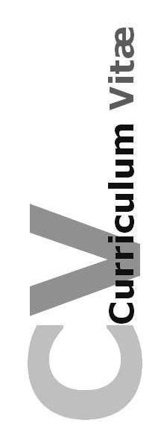**MIAN ALI HASSAN**

***Address:*** *C-101 firs floor sun view tower block 7 gulstan e johaar main university road karachi .*

***Contact No.*** *0334-2054242*

*Email: Alihasssanalwi@gmail.com*

CAREER OBJECTIVES

|  |  |
| --- | --- |
|  |  |

To work in organization where I can fully utilize my knowledge to achieve the highest efficiency and strive to promote the status of organization and to improve myself.

QUALIFICATION:

|  |  |
| --- | --- |
|  |  |

**MATRICULATION 2010**

Passed in Grade **“A1”**

B.I.S.E Hyderabad.

**INETERMEDIATE 2012**

Passed in Grade **“A”**

B.I.S.E Hyderabad.

**Electrical Engineering 2018**

Passed in Grade/ GPA “3.1”

From

Mehran University, Jamshoro.

OTHER QUALIFICATION

|  |  |
| --- | --- |
|  |  |

* 4 months certificate of **Microsoft Certified System Engineer** from **SZABIST ZABTech (iTVE)** Tando Muhammad Khan by BBSYDP.
* Certificate of Proficiency **(2nd Position)** From **Sindh Student’s Struggle.**
* Certificate of English language from stream line English language centre.

COMPUTER SKILLS

|  |  |
| --- | --- |
|  |  |

* Windows XP/7/8, MS-OFFICE 2007, Adobe Photoshop and Internet browsing.

PERSONAL INFORMATION

|  |  |
| --- | --- |
|  |  |

* **Father’s Name : Mian Muhammad Hassan Alwi**
* **Surname : Sayed**
* **CNIC : 4160106160183**
* **Date of Birth : 04-01-1995**
* **Domicile : Thatta**
* **Marital Status : Single**
* **Nationality : Pakistani**
* **Religion : Islam**

LANGUAGES:

|  |  |
| --- | --- |
|  |  |

* English (Read, Write, Speak)
* Sindhi (Read, Write, Speak)
* Urdu (Read, Write, Speak)