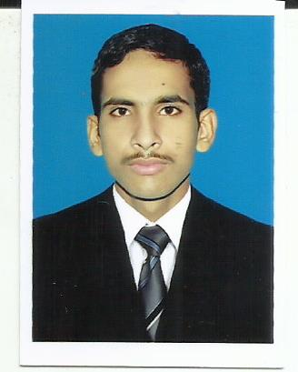**Muhammad Shahzeb Matloob**

S/o Matloob Hussain

House no. 20E/102 POF WAH CANTT

Mobile: 0334-0981260

E-mail: [Shahzaibmatloob77@gmail.com](mailto:Shahzaibmatloob77@gmail.com)

**Prime Objective:**

To achieve acknowledgment and experience in the relevant field with ever learning spirit and secure a competitive position in an organization for the utilization of acquired knowledge, skills and abilities.

**Academic Qualification:**

* dae mechanical: pbte lahore.

In first division (2012 to 2015)

* Matriculation: FBISE ISLAMABAD.

In first division (2012)

**Experience:**

* I have been working as a Junior Machinist at Hydrolink Engineering Equipment Company PVT Ltd Wah Cantt Since April 2016.

**COMPUTER COURSE OUTLINE:**

* 03 Months MS .Office Course from POF WCC Wah Cantt..
* 06 Months CIT Course from POF WCC Wah Cantt.

**TECHNICAL Skill:**

* 06 Weeks CNC Milling M/C Course from POF Institute of Technology Wah Cantt.
* 03 Months Auto-Cad Course from POF WCC Wah Cantt.

**Personal:**

Name: Muhammad Shahzeb Matloob

Father’s Name: Matloob Hussain

Date of Birth: 02 Dec, 1996

NIC Number: 37303-5897829-3

Domicile: Punjab

Nationality: Pakistani

Passport No: AS0408291

Date of Issue: 15 SEP 2016

Date of Expiry: 14 SEP 2021

Religion: Islam

**Reference:**

Will be provided on request.