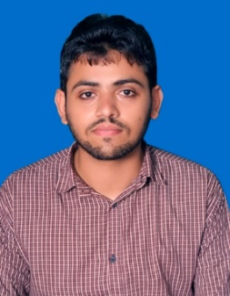**AHMAD RAZA**

**Address:** H#13,St#31,Aziz Colony Wandala Road Shahdara Lahore, Pakistan

**C.N.I.C. # 35401-3941231-9**

**Contact Number:** 0323-4209608

**Email:** ahmad93pk@yahoo.com

**D.O.B.: 5th** April 1993

|  |  |
| --- | --- |
|  |  |

#### CAREER OBJECTIVE

Seeking a challenging position, to apply my knowledge gained during studies, in a reputed Organization that utilizes my skills and provides me facilities to grow as a professional and enhance my knowledge and communication skills.

#### QUALIFICATIONS

|  |  |  |
| --- | --- | --- |
| **DEGREE/CERTIFICATE** | **BOARD/UNIVERSITY** | **DIVISION** |
| **Bachelor of Electronic Sciences (Hons)** | GOVERNMENT COLLEGE UNIVERSITY, LAHORE. | **First** |
| **DIPLOMA OF ASSOCIATE ENGINEER IN (ELECTRONICS)** | PUNJAB BOARD OF TECHNICAL EDUCATION LAHORE | **First** |
| **Matriculation(Science)** | BISE LAHORE | **First** |

#### MAJOR SUBJECTS

Data Communication & networking, Robotics & Industrial Electronics, Digital Signal Processing, Control System, Digital Electronics, Electronic Communication System, Microcontroller & Microprocessor Interfacing, Power Electronics, C++ Programming, Transducers & Instrumentations, EMT, Medical Electronics, Bio-Medical Electronics, Signals and systems.

#### Work Experience

**One Year experience in a shop.**

* Repairing of TV
* Repairing of UPS
* Repairing of stabilizer & other Electronic Devices.

|  |
| --- |
| **ACADEMIC PROJECTS** |

* Simulation Procedure as a Membrane Using ANSYS Software
* Calculator Designing Using C++ Languages
* DVM Designing
* Sensor Designing
* Robotic Designing

#### SKILLS

* **Communication Skills:**
* Presentation Skills.
* Technical Report writing skills.
* Group influential Communication and social skills.
* **Computer Skills:**
* Windows 7, 8 & 10, Mat lab, OOP (Programming in C++), Assembly language, Microcontroller Programming, Computer Hardware & Software Installation, MS Office, Research Methodology, Proteus

|  |
| --- |
| **ACHIEVEMENTS** |

Event Manager in Electronics Society.

Member of Ravines Quiz Society (GCU Lahore)

#### INTERESTS

* Technology, Utilization of Mathematical tools
* Research on Internet, Reading Islamic books
* Reading newspaper and watching news on TV

**(Reference will be provided on need)**