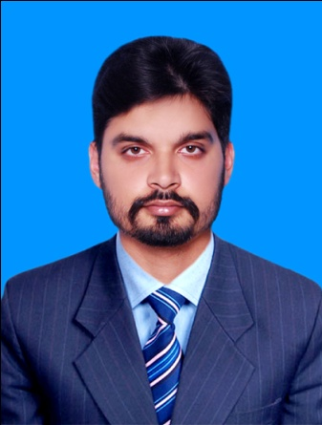**PERSONAL DETAIL Engr.** MUZZAMIL BAIG **(Registered Engineer) Registered with Pakistan Engineering Council.**

**Father Name: Shamim Ahmed Baig**

**CNIC:37405-0889509-7**

Nationality: **Pakistani**  Marital Status: **Single** Date Of Birth : **27/08/1993**  
Contact # **+92-346-5002233** Email ID # **mumilbaig@gmail.com**

**Academia**  
**BS-ELECTRONIC ENGINEERING** **3.22/4.00** (Completed in june 2016)

**MSc-ELECTRICAL ENGINEERING** ( In Progress )

From International Islamic University Islamabad

From University of Engineering And Technology (Taxila)

Matric from FEDERAL BOARD 77% score F.S.C from FEDERAL BOARD 65% score

**Career Summary**  
-Analytical and hardworking professional with proven experience in circuits and trouble-shooting.  
-Proficient in making the PCBs for various purposes.  
-Proficient in fields of electronics like analog electronics, digital electronics, embedded systems.  
-Excellent data analysis reporting skills using statistical methods.

**Personality Traits** -Remarkable speed and efficiency.  
-Detail oriented and strong interpersonal skills.  
-Ability to work in a team.  
  
**Technical Knowledge** -Expertise circuit handling, image processing, debugging the circuits.   
-Expertise in H-Bridge, Sensors, Comparators, Motor drivers  
-Proficient in various apparatus and technology which is been used in modern era. -Troubleshooting in circuits.

**Key Responsibilities Handled** -Head organizer of the events ROBOTICS, have strong management skills -Analyze the uses of the circuit and try to make it more cost effective.  
-Troubleshoot the problems and providing the best possible solution.  
-Maintaining the existing circuits

**Achievements -** Final year Project **BIONIC HAND CONTROLLED FLYING ROBOT**   
-Worked in the team who discovered the new way to communicate Robot through mobile.  
-Take part in international robotics contest. -Making of different kinds of robots. (Especially wireless). -Hand gesture controlled Robot -Making of inverter 12v DC to 220v AC. -Made Home automation system. -Designing of a model in PRO-Engineer. -Designed a solar tracking system.

### Experience 2-months Internship (Engineer) at [Weatherford International](http://www.weatherford.com/) Islamabad (Wireline Engineer)

1-Year Internship (Research) at Senate Secretariat, Parliament House, Islamabad.

6-Week Internship at NOC PTCL Islamabad.

**Additional Information** Will be further provided on demand.