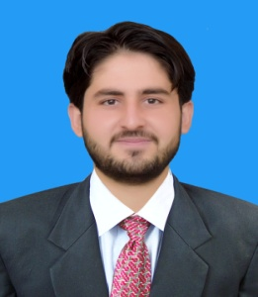 **Muhammad Rehan**

**P/O Billitang,village Razgir Banda,**

**District Kohat, KPK, Pakistan.**

**Email: rehaan121afridi@gmail.com**

**Tel: +92 3355743492**

Education

|  |  |
| --- | --- |
| 2011–2013 | **Peshawar Model Degree college , Pakistan**, *Faculty of Science*,  Pre-*engineering*. |
| 2013–2017  ACADEMIC CAREER | **University of Engineering and Technology Peshawar, Pakistan**, *Bachelor of Science*,Mechanical *Engineering*.   |  |  |  |  | | --- | --- | --- | --- | | Certificate/Degree | Session | Division % | **Board/ University** | | BS (Mechanical) | 2013-17 | 67.75% / 2.71 Cgpa | UET(PESHAWAR) | | F. Sc. (Pre-Engg) | 2011-13 | 87% | BISE(PESHAWAR) | | SSC(Science) | 2010-11 | 76% | BISE(Kohat) |   Interest and Expertise  Power systems  Manufacturing Processes  RAC  Power Generation & Utilization  Auto CAD software |
|  |  |
|  |  |

Certifications

|  |  |
| --- | --- |
| May 2010 –  Oct 2010 | Auto CAD Diploma (6 months) |

Skills & Abilities

|  |  |
| --- | --- |
|  |  |
| Software | MS Office. |

Projects

|  |  |
| --- | --- |
| Jan 2014  April 2015 | **Material testing (solid Mechanics)**  Robotic vehicle (mechatronics) |
| Jan 2016 | **Gear Train (Machine Design)** |
| Sep 2016  Sept 2017 | **Personilized Cooling device using PCM (Phase change material)**   * Design & Fabrication of cooling jacket (vest) having many practical applications. * Design & Fabrication of small cooling unit for room air conditioning. |
|  | |  |
|  | |  |
|  | |  |

Coursework

|  |  |
| --- | --- |
| - Control systems | - Machine Design |
| - Manufacturing Processes | - Fluid Mechanics |
| - Power Plants  -Production Automation  -Dynamics | - RAC  - Solid Mechanics  -Engineering Materials  -Engineering Metallurgy |

**Experience :**

Internship at kohat cement company.

Languages

English, urdu : Fluent