## toqir nasir

Electronic Engineer **(PEC-RE- ELECTRO/22376.)**

**Address:** Mohallah Khandiq Vill & P.O Kot-Najibullah District Harpiur KPK PAKISTAN

**Email Address**:[toqir_nasir@yahoo.com](mailto:toqir_nasir@yahoo.com)

**Contact : +92-313-5965450/340-1192970**

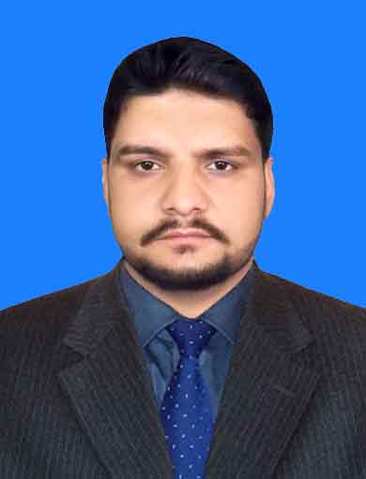

**Personal Objective:**

To start my professional career with a challenging environment in order to apply and enhance the various technical, management and decision making skills I have acquired during my academic Career.

**Profile:**

An individual with high motivation level and confidence on my abilities which can perform in any

working condition. Highly focused on achieving the given task successfully and efficiently, I have achieved and worked on following set of skills and believe to grow stronger with time and experience:

* Good communication skills
* Entrepreneurial mindset and enthusiasm to lead
* Good documentation and report writing skills
* Good managing and decision making skills

**Education:**

|  |  |  |
| --- | --- | --- |
| **Duration** | **Degree & Institution** | **%age/C.G.P.A** |
| 2010 – 2014 | B.E (Electronic Engineering) Dawood University of Engineering and Technology Karachi.  **PEC- ELECTRO/22376.** | 77.1%**/** 3.07 |
| 2007 – 2009 | H.S.S.C Board of Intermediate & Secondary Education Abbottabad. | 69.76% |
| 2006 – 2007 | S.S.C Board of Intermediate & Secondary Education Abbottabad. | 64.00% |

**Experience:**

**1- One month internship in Pakistan Steel Mill Karachi at following departments.**

* Electronic Development Cell
* Cold Rolling Mill.
* Iron Making department.
* Engineering Laborites.

**2**-**Three month Internship in HEC. Hattar Industrial State Hattar Haripur.**

To study the construction and process of 11KV Generation Transformer.

**3- Three month Training in National Radio Telecommunication Corporation Haripur at following departments.**

* Construction and Maintenance.
* Inventory control.
* SMT production.

**Final year project:**

## Control And Monitoring Of Oil Field System Through PLC And HMI .

Work Statement: Pressure, flow, level and temperature control of aqueous medium using ordinary sensors to avoid alarming situations. The whole system is on Fatek PLC.HMI to monitor all the system working’s.

**Skills & Abilities:**

**Engineering Software:** Multisim, Proteus, C++, PLC, HMI, ACI (laser machine), Cardex, SMT MACHINE(YAMAHA, COBRA,SAMSUNG).

**Application Software:** MS Office, MS Windows, SMT production software, web suffering software etc.

**Presentations:** Delivered around 10-15 presentations to an audience of approx. 40-60 people.

**Skills:** Team Player, leadership qualities

**Seminars &Workshops:** Workshop on training of PLC in UniTech Karachi (4 weeks) , Attended more than 15 seminars.

**Extra-curricular:**

# Playing, Cricket, swimming, badminton , Gaming, Reading books, Web surfing, Movies and Music..

**Personal profile:**

* **Father’s Name:** Muhammad Bashir (late).
* **NIC No. :** 13302-7687004-1
* **D.O.B. :** June27, 1990.
* **Marital Status:** Single.
* **Domicile:** Haripur, (K..P.K).
* **Nationality:** Pakistani.
* **Passport number:** JE9820041
* **Language:** English, Urdu, Hindko.

**Reference:**

Reference and further documents will be furnished upon demands.