**Khushal Muhammad** 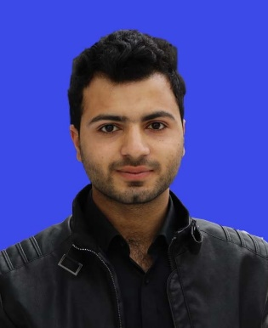

**Postal Address:** Tehsile & P.O Pabbi (24210), District Nowshera

**Address** Mohalla Taizai No.1 Pabbi, Nowshera Khyber Pakhton Khwa

Pakistan.

**Cell:**  +923369542304

**Objectives:**

To become a part of a dynamic group where I could further explore the skills and capabilities which I gained in the whole academic career and serve in a challenging work environment and to work in an environment with vast opportunities of career development based upon the achievements and results. I believe in honesty, simplicity, teamwork and commitment.

**Personal Data:**

Father Name: Wisal Muhammad

Date of Birth: 02 December 1992

Domicile: Nowshera (KPK)

Nationality: Pakistani

C.N.I.C No: 17202-0340128-1

Passport No: DY0161281

Religion: Islam

Marital Status: Single

E-Mail Address: [Khushal14941@gmail.com](mailto:Khushal14941@gmail.com)

**Education:**

|  |  |  |  |  |
| --- | --- | --- | --- | --- |
| **Qualification** | **Year** | **Marks/**  **GPA** | **DIVISION** | **Board/**  **University** |
| MS( Electrical Engineering) Enrolled | Course work completed | 3.0 Out of 4 |  | Iqra National University |
| Bachelor Of Electrical Engineering | 2016 | 2.8 Out of 4 | 1st Division | Iqra National University Peshawar |
| H.S.S.C | 2011 | 676/1100 | 1st Division | BISE Mardan |
| S.S.C | 2009 | 682/1050 | 1st Division | BISE Mardan |

**Final Year project (bechelor of electrical engineering)**

* **Line Follower And Obstacle Avoidance Robotic Vehicle:**

Robots can help humans in places where human access is limited, like hazardous waste site, and thermal/nuclear power plants. Line following and obstacle avoiding robots are intelligent robots that can perform desired tasks in any environment. This robotic vehicle having ability to follow the path by itself and also detecting the hurdle comes on its path and to avoid it.

**Major cources:**

Power Generation, Power Transmission & Distribution, Industrial Electronics, Circuit

Analysis, Electrical Machines, Power Electronics, Control Systems, Digital System

Design, Electronics Circuit, Digital Logic Design, Embedded System.

**Work experience:**

* **Internship at Ghazi Barotha Hydropower Complex:**

I had successfully completed internship & practical training w.e.f “ June 2014 to July 2014” at (1450-MW) Ghazi Barotha Hydropower Complex- Attock.

**Technical skills:**

* **Computer Skills:**

Have knowledge about Win XP/7/8/10, Ms Office (Ms Word, Power Point, Excel), Photoshop, Coral Draw, Auto Cad, Hardware, Typing Speed upto 35 words per Minutes,

* **Personnel Skills:**

PCB Designing, Soldering, Programming, Hardworking, Responsible and Skills to Teach.

* **Network Simulators and Tools Kit :**

Matlab, Eagle Software, Dip Trace

* **Programming/Scripting :**

C, C++

* **Circuit Designing Tools :**

Multi-sim, Arduino, AutoCAD.

**Languages:**

English - Spoken and written - Fluent

Urdu - Spoken and written - Fluent

Pashto - Spoken and written - Mother Tongue

**Refrences:**

Will be furnished upon demand.