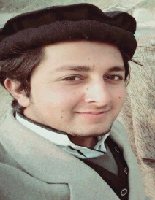

**Curriculum Vita (CV)**

**HARIS MAHMUD**

**Diploma in Associate Engineering IN ELECTRICAL (DAE)**

**CAREER OBJECTIVE**

**To secure a position in an organization that would fully employ my personal skills, my experience as well as my academic training in a rewarding career that affords professional and personal growth.**

**Name: Haris Mahmud**

**F/Name: Arshad Mahmud**

**Address: Mohallah New Aba Khel Nowshera Kalan, Tehsil and District Nowshera.**

**Domicile: Nowshera, Khyber Pakhtunkhwa.**

**CNIC # : 17201-8692677-3**

**Birth Day: 25-12-1997**

**Religion: Islam**

**Nationality: Pakistani**

**Material Status: Un-Married.**

**BASIC ACADEMIC CREDENTILS:**

|  |  |  |  |  |
| --- | --- | --- | --- | --- |
| **Qualification** | **Board/University** | **Year** | **Marks** | **Percentage** |
| **S.S.C(Metric)** | **BISE Mardan** | **2014** | **625/1100** | **57%** |
| **Diploma in Associate Engineering (Electrical)** | **Technical Board Peshawar** | **2017** | **2335/3550** | **66%** |
| **B.Tech( Electrical) Continued**  **(Through EATA Test)** | **Govt College of Technology Peshawar** | **2018**  **(Ist Year)** |  |  |

**Computer Skill:**

**MS Office, Internet, AutoCAD.**

**Language Proficiency:**

**Pashto, Urdu, English.**

**Email:** [**arshadmahmud73@gmail.com**](mailto:arshadmahmud73@gmail.com)

**Call: 0333-9009029 0311-9933033 0311-9163125**