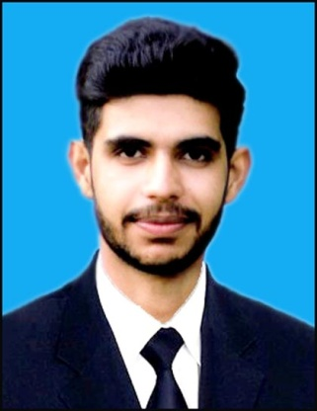ATEEQ-UR-REHMAN

**+92-331-5220140**

**Arehman_che07@scme.nust.edu.pk**

**www.linkedin.com/in/ateeq-ur-rehman-nust**

# OBJECTIVE

To pursue a challenging position in an engineering environment where my resourceful experience and academic skills will add value to organizational operations and management skills

# EXPERIENCE

|  |  |
| --- | --- |
| **OIL AND GAS COMPANY Limited (OGDCL) Pakistan**  14236-200.png Islamabad Head office and Dakhni Plant | **Jul, 2017- Aug, 2017** |
| **NORTHERN GAS Pipelines Limited (SNGPL) Pakistan**  14236-200.png Islamabad Head office | **Jul, 2016- Aug, 2016** |
| * Worked as site engineer under the supervision of highly experienced engineers * Learned the problem-solving methods, structure of the department and job purposes of staff members * Collaborate with staff of Operation department, Distribution department & Corrosion department | |

# EDUCATION

|  |  |
| --- | --- |
| **Bachelor of Chemical Engineering**  NUST School of Chemical and Material Engineering (SCME) | **SEP 2014- JUN 2018** |
| **FSc. Pre-Engineering**  Punjab College Blue Area Islamabad, Pakistan | **SEP 2012- SEP 2014** |
| **Matriculation**  Islamabad Model School For Boys, Pakistan | **SEP 2010- SEP 2012** |

# Final Year Project

**Process Design and Simulation of Urea Synthesis Process**

* A process model is developed within **Aspen PLUS and Aspen HYSYS** environment to observe the real plant behavior.
* **Sensitivity Analysis** of model, comprising of **4000 samples** which are generated through MATLAB-Excel-Aspen interface.

# HS&E Course

**Certified by Punjab Government of Pakistan**

* Understand and learn the HSE Management System Policies, Guidelines and Standards issues.
* Assists the Commercial, Engineering and Operations Department in their dealings with Clients in issues concerned with Health and Safety at work.
* Conducts safety audits and performs Risk Assessments.

# Skills

IT Expertise

* ASPEN HYSYS
* ASPEN PlUS
* Microsoft Office
* AUTOCAD
* MATLAB
* C++ Programming

Sportsmanship

* SCME Indoor Games

Consecutive winner for three years

* Football and Badminton player at University level
* Member of Madias Hockey Club, Islamabad

# ACHEIVEMENTS

* **Director of Nust Bio-reach Society**
* **Executive of NUST Community Service Club**

These societies have aim to providing a platform for young researchers to share their scientific ideas and promote intelligent debate among the future scientists. Furthermore, public health awareness initiatives form a key part of their agenda.

* **NBIOS OUTREACH PROGRAMME**

Start working with NBIOS for education empowerment, supporting learning and exploring science by help of The **Stanford University** and the inventor of **Foldscope, Mr. Manuprakash**.

* **Science Competition of CHEMFEST’17**
* Runner-up at University level
* **Event Head**
* Water Conservation and Health Promoting Project
* Health Camp for Nustians of Islamabad Campus

# Languages

* English
* Urdu