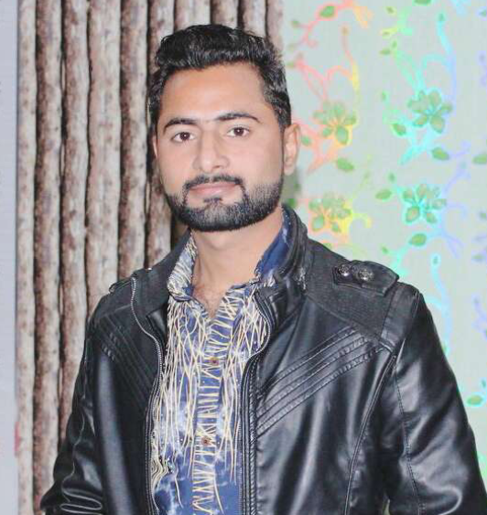**HAMZA SALEEM**

**PERSONAL DATA**

Name : HAMZA SALEEM

Father name : MUHAMMAD SALEEM

Qualification : BS Mechanical Engineering & Technology

Religion : Islam

Date of Birth : 01-Dec-1995

CNIC No : 37105-3054209-3

Domicile : Attock, Punjab

Languages : English, Urdu, Punjabi

Marital Status : Single

Nationality : Pakistani

Postal Address : Village & P/O SHEHBAZ PUR, TEH: PINDI GHEB, DISTT:

ATTOCK

Permanent Address : Village & P/O SHEHBAZ PUR, TEH: PINDI GHEB, DISTT:

ATTOCK

Contact No : +923379845751

E – Mail : [rajahamzah1995@gmail.com](mailto:rajahamzah1995@gmail.com)

**CAREER OBJECTIVE**

To work in the dynamic, team oriented, competitive and cooperative environment in a reputable organization, where the chances of learning and growth as a proficient, innovative and committed person can be maximized.

**ACADEMICS**

|  |  |  |  |
| --- | --- | --- | --- |
| **Duration** | **Qualification** | **Institution** | **Percentage/CGPA** |
| 2014-2018 | **BS Mechanical Engineering Technology** | University of Wah,WahCantt | **2.9/ 4.00**  **750%**  Result Awaiting |
| 2012-2014 | **FSc Pre- Engineering** | KALLAR KAHAR SCIENCE COLLEGE KALLAR KAHAR | **1st Div** |
| 2010-2012 | **Matric– Science** | OXFORD PUBLIC SCHOOL PINDI GHEB | **1st Div** |

**PROJECT**

**Final Year Project**

**Design and Fabrication of Multi-purpose/Multi-operation Machine for Mechanical Operations**

The project aim is designing and developing a multi-purpose/multi-operation machine tool which can perform multiple task simultaneously as well as individually. The objectives of the machine are conservation of electricity (power supply), reduction in cost of manufacturing, increasing in productivity and reduced floor spaced requirements.

**Minor Projects**

* **Hydraulic arm**: Operated with syringes with nozzles.
* **Robotic car:** Operated with android mobile with the help of software. ( Bluetooth mobile control )
* **Wheel chair:** Design a comfortable wheel chair for disable person

**KEY SKILLS**

**Academics**

In depth knowledge of Mechanical Engineering concepts

Excellent written and verbal communication skills

Knowledge of different software related to design

Superior experience of working with different Mechanical instruments

Knowledge of Health and Safety environment in an organization or industry

**Software**

CREO , OFFICE ,

**Computer**

Having a sound knowledge of MS Office, (MS Word, MS Excel, and PowerPoint).

Having a sound knowledge of internet, web browsing.

Having a sound knowledge of computer.

**CERTIFICATES & ACHIVEMENTS**

* Two months training related to Mechanical Engineering in process from**“WAH BRASMIL pvt”.**
* Two months training related to mechanical operations from “**POFIT**” wah cantt.
* Certificate of “**Cadet Training**” of 3 months from Cadet Coacing academy.
* Certificate of “**Spoken English**” from Cadet Caching academy.
* Certificate of “**Pro-e**” from Virtual institute (**WAH CANTT**).
* Certificate of “**Spoken English**” from POF institute (**WAH CANTT**).
* Certificate of “**HSE Awareness**” from (**EIOSH** pvt.ltd**).**
* Certificate of “**3D Designing**”in **PIEAS NATIONAL OLYMPIAD’18** held in PIEAS University Islamabad
* Certificate of participation in “**CRICKET**” in **AIR NEXUS’18** held in Air University Islamabad.

**rEFERENCE**

References will be given upon request